e Official Publication of ALOA—An International Association of Security Professionals



Braving the Deep with the Marks iQue • By Greg Perry CML, CPI

*******************2-[)lGiT 303

Breck H. Camo CML PO Box 47070 Atlanta GA 30362-0070

liiililf m.iliiiSSiiiiSiiHiiiHiiif iiiillmtiiiSSiimiiiif

Plus:

“Cycle Chronicles ” Hunts Down a Polaris ATV,  
The Dog and Pony Show, IAIL Convention Coverage,  
a Markar Factory Visit, Understanding Use and  
Occupancy Classification  
and more!

Your Future

Join us next summer at the East Coast's premiere travel destination as we set the stage for the biggest security event in the world. Come to Baltimore and discover classes, workshops, and exhibits that will help you shine in today's marketplace.

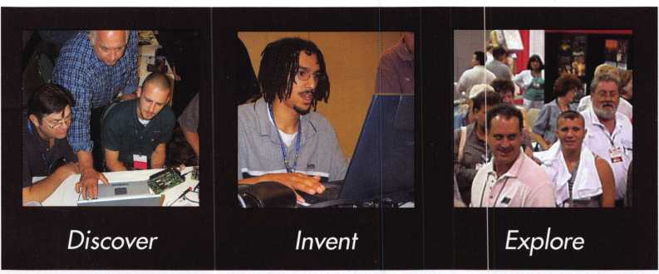

Ml-TtMORE, Ml?

get it... together

The ALOA Convention and Security Expo • Baltimore Convention Center • July 19-25, 2004 • (800)532-ALOA(2562)

[convention@aloa.org](mailto:convention@aloa.org) • [www.aloa.org](http://www.aloa.org)

**Pearl Technical Sales**

***featuring sex bolt solutions from***

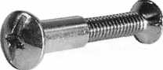

£



Sex Bolt Hardware and Fasteners - In stock for immediate shipment.

* Sex Bolts - Standard and Custom Sizes • Custom Service
* Sex Bolt Assortment Kits • 50 Piece Minimum custom order
* Barrel Bolts • Quick TurnAround
* Binding Posts • CNC manufactured, Top Quality
* Connecting Bolts • Brass, Stainless Steel, and Steel materials

• Architectural finishes

TECHNICAL SALES, INC.

17Timbercrest Lane  
South Setauket, NY 11720

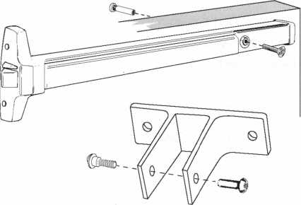

Phone:631-698-7173 • Fax: 631-736-5467

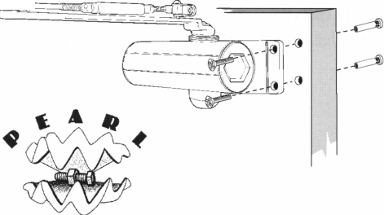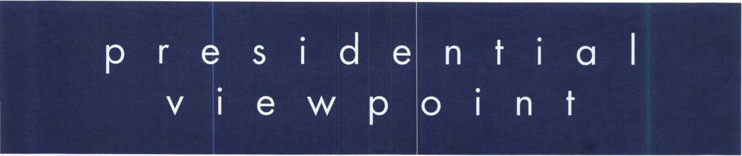

Dear Members,

It is a relief and a thrill to have completed my first Board Meeting as your president.

I once again would like to thank the officers and members of the Pacific Locksmith  
Association for being such generous and gracious hosts.

I was very pleased with the discussion and decisions that were made at this meeting.

I am not going to go into detail here about what was discussed because the Board decid-  
ed to post the minutes of the board meeting in the members' section of the web site  
([www.aloa.org](http://www.aloa.org)), and a summary Board report has been included in this issue of  
"Keynotes" (page 10). These actions were taken to give the members a better concept of

what goes on at these meetings, and to encourage participation.

I am going to go into some detail about some decisions that were made that will involve bylaws changes. First, the Board decided that in future elections, a candidate for president must be a sitting member of the Board of Directors, or have served on the Board within the past three years. The reasoning behind this is that the Board feels that the president must have experience with policy governance and be familiar with its intricacies. The Board agrees that policy governance is the most effective way for an association that has a paid staff to govern itself.

Secondly, the Board has decided to eliminate one trustee. Currently, the trustees consist of the three most recent past presidents of the association. The reasoning behind this is to shorten the length of service for persons seeking the role of president. For example, a presidential candidate has already served one or more terms as director, then would serve two years as president, and then, six more years as trustee. This is an unusually long commitment, and may discourage an otherwise capable candidate from running.

Third, the Board, through the Executive Director, is exploring the creation of a company membership as a prelude to the shop certification program that is in the works. If this action is taken, a bylaws change is necessary because a new category of membership would be created. I encourage the membership to accept these changes when the time comes.

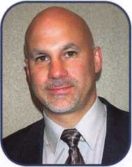

This issue of "Keynotes" deals with electronics. While not an expert on this subject, I have seen the need to have electronics experts on my payroll to keep up with technology and remain competitive by actively soliciting this type of business. Access control will continue to touch our lives in ways that we may have never suspected in the past. Read on and learn!

William L. Young, CML

Keynotes • December 2003

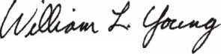

*'mm*

***Visit our Website on  
www. stamcctv. com***

THE COMPLETE

CCTV PROGRAM ON CD-ROM  
FOR STAFF TRAINING AND

PRODUCTIVITY ENHANCEMENT

STAM **Insight** has been  
developed to enhance CCTV  
skills and productivity with  
many different uses.

**I#** Productivity

<1# System Drawing  
I# Estimation  
I# CCTV Training  
I# CCTV Reference  
t# Sales/Demo  
w System Design  
**k0** Staff Evaluation

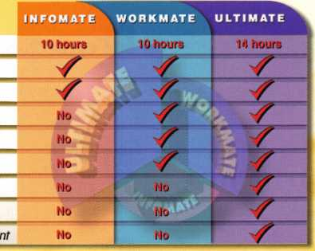

CCTV Content

CCTV Calculators

Demonstration Tool

Estimation

Drawing

Internet Enabled

**Sold in Over 50 Countries**

Distributed by:

3003 Live Oak Street  
Dallas,Texas 75204



■ Yes, please send me a FREE PREVIEW CD ROM $9.95 S/H

Name:

Job Title:

Organization:

Address:

Zip/Postcode

Country e-mail

Tel: ( ) Fax: ( )

COPYRIGHT © 1996 Security Training and Marketing Pty Ltd. All rights reserved ACN 057 006 541

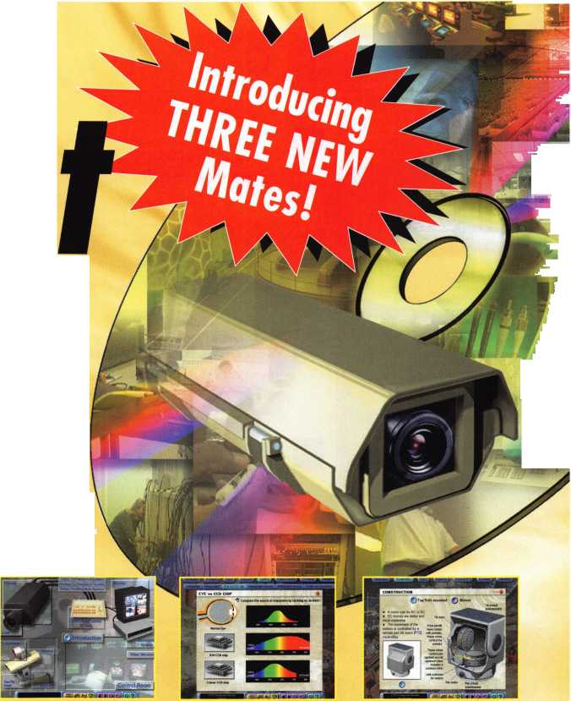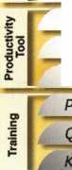

f

e

a

t

u

**res**

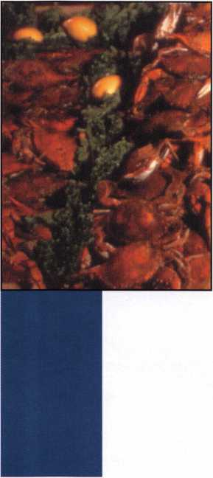

Cover - Electronic Locks—Strong Enough for Sailors?

Inside the Marks iQue **b**xGreg Perry, cml, cps

We have a Navy base next to us, with sailors whose primary mission is to kill people and break things. And trust me, these guys know how to break things. They've broken mechanical pushbut­ton locks by the hundreds. The only area of weakness or concern is the membrane keypad. It may not hold up to the abuses of sailors I spoke with a Marks representative, who had the fac­tory send us a lock to try. We're waiting for our customer to break an old lock, so we can install the Marks iQue.



Welcome to Baltimore—The ALOA '04 Convention Location By Claire L Cohen This year the ALOA Convention will be held in Baltimore, MD, from July 1 8-25, 2004. If you are planning to come to Baltimore a day or two before the convention or stay after the conven­tion, area attractions are plentiful.



Institutional Locksmithing: Understanding Use and Occupancy

ClaSSlf ICatlOn ByDaveThielen,CML

Understanding Life Safety Codes is an important skill; we should all take pride in learning them. Although not the most glamorous or exciting subject, it is important to understand basic codes such as NFPA 80, NFPA 101, etc. In this article, we will explain some of the mystery of Use and Occupancy classification.



Markar Factory Visit **ByRayigiesias,cPL**

Lately, I have been looking to expand my services and product line. To grow my locksmith busi­ness in Fort Lauderdale, FL, I knew that I needed to offer my customers more. But at the same time, I needed something that could compliment my existing product lines. Lastly, I needed to use existing techs with minimal investment in tools and training, and of course, be profitable. Enter Markar.

**departments**

Executive 5

Applicants 6

Calendar 8

Core 10

Legislative Update 38

Classifieds 40

Associate

Members 42

Back Page 44

**26**

Cycle Chronicles, Part 2: The Polaris ATV By Raymond D'Adamo, CML

Recently, the owner of a 2000 Polaris 500 four-wheel ATV called to ask what it would cost to have a key made for the ignition switch, which is the only lock on the vehicle. He said he lived alone and probably did not have the strength to push it up a pair of ramps and into his pickup, so he decided to remove the switch and bring it in. Then he asked me how to remove it.



IAIL Show Attendees: "We Didn't Want the Classes to End!" By Claire L. Cohen, CML The classes were so interesting that "we didn't want the classes to end." IAIL recently held their second annual at the end of August, at the Wyndham Hotel in Mt. Laurel, NJ.

**34**

Are you using "Miraculous Pricing?" bxRichardl Dyer, crl, cps, **as**

Being successful and profitable is very important to most business owners. The ideas and meth­ods used to achieve this vary from one business to another. There is no single correct method for being successful and profitable. Being successful is tough because of all the variables involved.

Your individual skills are very important in developing a successful business.

**36**

The Dog and Pony Show **bx**Ericcostiey, crl

As the season for excess creeps upon us, I'd like to rattle a few cages concerning gadgets and showmanship as an integral part of our profession. As a rule, our goal as locksmiths is to remain as professional as possible, providing timely service for a fair price. However, the public doesn't always see it this way.

Visit

our website at [www.aloa.org](http://www.aloa.org)

**executive**

Volume 49, Issue 11



Additional contact information for the ALOA Board and most Keynotes authors is  
available through "Locksmith Search'" on the ALOA Web site-[www.aloa.org](http://www.aloa.org) or by  
contacting the ALOA office at 3003 Live Oak Street; Dallas, TX 75204; (800)532-2562;  
FAX (214)827-1810; e-mail [aloa@aloa.org](mailto:aloa@aloa.org).

|  |  |
| --- | --- |
| Editor  Jim DeSimone | [editor@aloa.org](mailto:editor@aloa.org) |
| Technical Editor  David Lowell, CML, CMST .... | [david@aloa.org](mailto:david@aloa.org) |
| Editorial Advisor  John D. Cannon, CML | [jdcannon@worldnet.att.net](mailto:jdcannon@worldnet.att.net) |
| Art Director  Betty Henderson | [betty@aloa.org](mailto:betty@aloa.org) |
| Advertising Sales  Kim Hammond | voice; 817-645-6778  Fax: 817-645-7599 e-mail: [adsales@aloa.org](mailto:adsales@aloa.org) |
| Executive Director  Charles W. Gibson, Jr., CAE | [charlie@aloa.org](mailto:charlie@aloa.org) |
| Convention & Meetings Manager  Jo Anne Mims [joanne@aloa.org](mailto:joanne@aloa.org) | |

PRP/Education Manager

David Lowell, CML, CMST [david@aloa.org](mailto:david@aloa.org)

Operations/Membership Manager

Mary May [mary@aloa.org](mailto:mary@aloa.org)

Government Relations Manager

Paul Kanitra [paul@aloa.org](mailto:paul@aloa.org)

IT Operations Manager

Greg Jackson [greg@aloa.org](mailto:greg@aloa.org)

Comptroller Kathy J. Romo

Membership Coordinator Shelly Jett

Convention & Meetings Assistant Karen Lyons

PRP/Education Coordinator Esperanza Rodriguez

Accounting Coordinator Stephanie Brothers

Mail Room Coordinator Kevin Wesley

Receptionist Bryan Dease

Contributors

Jerome Andrews, CML  
Paul Chandler, CRL  
Claire Cohen, CML  
Brian Costley, CML, CMST  
Eric Costley, CRL

Ray D'Adamo, CML Sal Dulcamaro, CML Billy Edwards, CML Dan Graffeo, CRL,CMST Jim Hancock, CRL

AJ. Hoffman, CML Jeff Nunberg, CML, CMST Randy Simpson, CML Robert Stafford, CML Dave Thielen, CML

Greg Perry, CML,CPS Tom Seroogy Charles Stephenson, CPS Dennis Watanabe, CML, CMST

**Mission Statement:** The Associated Locksmiths of America, Inc. is dedicated to enhancing the professionalism, education and ethics among locksmiths and those in related sectors of the physical security industry. With approximately 10,000 members in the United States, Canada and the freeworld, ALOA is poised to help members obtain the knowledge, the strength, and the confidence to perform their role in the physical security field with pride and dignity. But it is only through active involvement and participation that ALOA can fully achieve its potential—and can help members to achieve theirs.

**Policies:** Keynotes® is the official publication of the Associated Locksmiths of America, Inc. (ALOA). Keynotes® acts as a moderator without approving, disapproving, or guaranteeing the validity or accuracy of any data, claim, or opinion appearing under a byline or obtained or quoted from an acknowl­edged source. The opinions expressed by the authors do not necessarily reflect the official views of ALOA. Also, appearance of advertisements and new products or service information does not constitute an endorsement of products or services featured by the Association. The Association does not accept responsibility for the inaccuracy of any data, claim, or opinion appearing in this publication, due to typographical errors on the part of the authors, Association staff or its agents.

**Editor's Note:** This publication is designed to provide accurate and authoritative information in regard to the subject matter covered. It is provided and disseminated with the understanding that the publisher is not engaged in rendering legal or other professional services. If legal advice and other expert assistance is required, the services of a competent professional should be sought.

**Authors' Payment:** Payment for eligible submissions to Keynotes will be based on the following criteria: topic, time spent and past contributions. Authors who regularly submit to Keynotes® are generally paid a higher rate. The latter is especially true of authors who write to fit specific editorial needs and submit said copy by Keynotes® deadlines. As a general guideline: Average payment for a 750 word, business or 'light' technical article would be $200. Payment for a 1500 word article involving significantly higher time and research efforts would be $400.

Payment will not be offered for articles submitted by ALOA employees or members of the ALOA Board of Directors (unless material is of a technical nature), nor for articles submitted by a company that promote that company's products or services. ALOA reserves the right not to pay for articles sub­mitted by an individual(s) that promote a particular company's products or services.

**Disclaimer:** The Associated Locksmiths of America, Inc., (ALOA), reserves the right to refuse any article for any reason. Additionally, ALOA reserves the right to edit, amend or modify any article submitted for publication in order to preserve technical accuracy, clarity, fairness or grammatical cor­rectness. ALOA will make the best efforts to notify the author of any changes. The extent of ALOA's liability for any article or information contained therein will be a notice of correction or retraction in the next possible issue.

Keynotes® (ISSN 0277 0792) is published monthly except for the combined June/July issue by The Associated Locksmiths of America, Inc., 3003 Live Oak St., Dallas, TX 75204-6186. Telephone: (214) 827-1701; FAX (214) 827-1810; e-mail [aloa@aloa.org](mailto:aloa@aloa.org). Subscription rates for members—$15.00 per year. Periodical class postage paid at Dallas, Texas. POSTMASTER: Send address changes to: Keynotes, 3003 Live Oak St., Dallas, TX 75204-6186. © Copyright 2003, All rights reserved. No part of the contents may be reproduced or reprinted in any form without prior written permission of the publisher.

President

William L. Young, CML  
(610)647-5042  
[presidenf@aloa.org](mailto:presidenf@aloa.org)  
Secretary  
John D. Cannon, CML  
(703) 960-6413  
[secretary@aloa.org](mailto:secretary@aloa.org)

Directors, Northeast

Robert E. Mock  
(856) 863-0710  
[nedirector@aloa.org](mailto:nedirector@aloa.org)

Peter Sarailian, CRL  
(973)890-9797  
ned irector@aloa. org

William L. Young, CML

(610) 647-5042  
ned i rector@aloa. org

Directors, Southeast

Tom Gillingham, Jr., CML, CPS  
(615)264-0747  
sed i rector@aloa. org

Ken Kupferman, CPL  
(813)961-5784  
sedirector@aloa.org'

Directors, North Central

MarkE. Blum, CML, CPS  
(517) 482-5809  
n cd i rector@aioa. org

John Soderland, CML, CMST  
(414)327-5625  
[ncdirector@aloa.com](mailto:ncdirector@aloa.com)

Director, South Central

CD Lipscomb, CML, CPS  
(903)874-3522  
[scdirector@aloa.org](mailto:scdirector@aloa.org)

Directors, Southwest

Gordon R. Racine, CML  
(719) 384-4707  
swd i rector@aloa. org

Julie McCluney, CRL  
(714) 636-5652  
swd i rector@aloa. org

Director, Northwest

Scott L. Henke, CPL, CPS  
(907} 248-3785  
n wd irector@a!oa .org

Director, European

Hans Mejlshede, CML  
(453)539-3939

[eurdirector@aloa.org](mailto:eurdirector@aloa.org)

Director, Asian

joe j. Lee, CRL

(215)289-2404  
asiandirector@aloa .org

Director, Associate

Paul M. Justen  
(800)333-6953  
[asdirector@aloa.org](mailto:asdirector@aloa.org)

Trustees

[trustees@aloa.org](mailto:trustees@aloa.org)

Randy Simpson, CML  
(281)240-5959

John J. Greenan, CML, CPS  
(773) 486.2030

Dallas Brooks  
(334) 826-8990

Past Presidents

2001-2002 Randy Simpson, CML  
1999-2001 John Greenan, CML, CPS  
1997-1999 Dallas C. Brooks  
1995-1997 David Lowell, CML, CMST  
1993-1995 Breck Camp, CML  
1991-1993 Henry Printz, CML  
1989-1991 Evelyn Wersonick, CML, CPS  
1987-1989 Leonard Passarello, CPL  
1985-1987 Joe Jackman, CML  
1983-1985 Stanley Haney, CPL  
1981-1983 Louis LaGreco, CPL  
1979-1981 John Kerr, RL  
1977-1979 Clifford Cox, CML  
1974-1977 Charles Hetherington  
1972-1974 Gene Laughridge  
1970-1972 William Dutcher, RL  
1968-1970 Constant Maffey, RL  
1966-1968 Harold Edelstein, RL  
1964-1966 William Meacham  
1962-1964 Robert Rackliffe, CPL  
1960-1962 Edwin Toepfer, RL  
1956-1960 Ernest Johannesen



Keynotes • December 2003

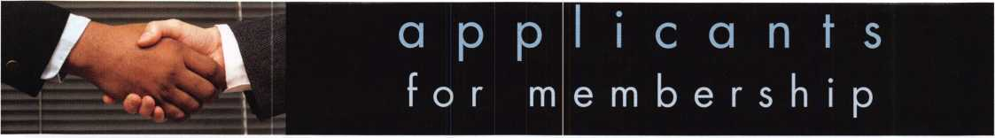

|  |  |  |  |  |
| --- | --- | --- | --- | --- |
| AL |  | IA | Brewster | NV |

**Florence**

James D. Peebles Jr

Sponsor: John P. Luhrs CRL Jackson

Larry Smith

Sponsor: Bruce J. Tarbet CML, CPS

**Phoenix**

John W. Jarzabek

Sponsor: William Lee CRL

Patricia Lee

**San Jose**

Waylen Fong

Sponsor: Jerrold G. Antoon RL, CPP

Randy Ngo-X

**Colorado Springs**

George G. Hruby CPL

**Fort Collins**

Tom Martinez

Sponsor: Wayne Younger CML

a

**North Haven**

David IGardetto

Sponsor: Vincent J. Longobardi Waterford

Peter Doherty

Sponsor: James P. Radack Woodbury

Richard Stoughton

**Crestview**

Deri Justice

Sponsor: Bruce J. Tarbet CML, CPS Loxahatchee

John W. Potts

Sponsor: Vincent L. Formon CML, CPS Orange Park Lisa R.B. Daugherty Sponsor: Bruce R. Bortz CRL

**Columbus** Stephen Parker **East Ellijay**

Bruce N. Reagin

Sponsor: John C. Elliott Jr, CML, CPS Eastman

E M. Harrington III

**Reinbeck**

Robert F. Gutknecht Sponsor: Rick W. Barrett

**Cicero** David Morin **Clare**

Holly M. Bingham

Sponsor: Jerrold G. Antoon RL, CPP

Walter O. Bingham

Sponsor: Jerrold G. Antoon RL, CPP Collinsville

Stephen W. Barbee

Sponsor: William T. Beranek Countryside

Robert F. Mance

Sponsor: William T. Beranek Steger

Ronald E. Urzendowski

Sponsor: William T. Beranek

Cory Smith

Sponsor: Jeffery B. Winslow

Baltimore

**Bloomington**

Ian Kvale

**Ligonier**

Dale Boyer

**Kansas City**

Charles E. Wendt CRL

Sponsor: Clifford D. Lipscomb CML, CPS

**Overland Park**

David J. Moore

Sponsor: Clifford D. Lipscomb CML, CPS

**Houma**

John D. LeBlanc

Sponsor: Bruce J. Tarbet CML, CPS Natchitoches

Craig Bumgardner

Sponsor: Bruce J. Tarbet CML, CPS Walker

Eric E. Jones

Sponsor: Randall R. Jones CRL

**Amherst**

Robert Osgood

Sponsor: Marcia A. Daniels

Ed Korenge

Hallowell

Jeffrey S. Truman CRL

**Comins**

Paul A. Badoni

Sponsor: William T. Beranek

**Minneapolis**

Bradley J. Freund

Sponsor: Dana L. Lee CML

Dale Schaar

**Blue Springs**

Frank L. Goetzfridt

Sponsor: Rollin R. Gilliland CPL, CPS Creve Coeur

Willie McConnell

Sponsor: Ron L. Scott Grandview

Thomas C. Healey

Sponsor: Clifford D. Lipscomb CML, CPS

**Roxboro**

Steven Spencer

**Florham Park**

David Kormann

Sponsor: Matt Blaze Paterson

Gary Powell

Sponsor: William L Young CML Sicklerville

Andrew Jankowski

Sponsor: Robert E. Mock

Albuquerque Michael W. Trahan

**Elko**

Charles D. Price

Sponsor: Robert R. Hecht

**Brooklyn**

Joseph Jankauskas

Sponsor: William L Young CML Utica

Paul M. Sacco

Sponsor: Paul C. Sacco CRL Webster

Joel Snell

Sponsor: Steven M. Trumbull

**Tulsa**

Erik Garner

McMinnville

Jody S. Fisher CRL

**Chester**

Michael S. Knepper

Sponsor: Robert E. Mock Harrisburg

John F. Shinkowsky

**Philadelphia**

John E. Messatzzia

Sponsor: William L Young CML

Edward T. Walsh Jr

Sponsor: Joseph R. Reustle

Adam Bosak

Sponsor: Joe J. Lee CRL

**Westerly**

David D. Syren

**Carrollton**

Chris M. Ortiz CRL

Sponsor: Dawn M. Forgey CRL

Jon T. Bottoms

**Kaufman**

Michael T. Barker

**Lake Dallas**

James Forgey

**Mesquite**

Charlie Criswell

**Richardson**

Thomas Bullock

Sponsor: Randy L Hutchison CRL Wharton

Raymond I. Meleton

Sponsor: Roy W. Umfleet

**VA**

**Charlottesville**

Robert A. Marshall

Sponsor: Stewart K Brown III, CRL

David R. Handy

Sponsor: Troy G. Miller CML

Wl

Beloit

John R. Stewart

**Kiel**

Dave W. Guckeisen

Sponsor: Jerrold G. Antoon RL, CPP Madison

Jesse Vazquez

Sponsor: Tom Ripp

**WV**

**Martinsburg**

Ian A. Edwards

Sponsor: Thomas W. Oliver

**Canada**

**Mississauga, ON**

Alvin Dorder

Sponsor: Robert E. Mock Penetany

Sean W. Baxter

Sponsor: Robert E. Mock Thornton

William A. Rawn

Sponsor: Robert E. Mock

**□land**

**Crawley West Sussex**

Mark Bosher

Sponsor: Ken Dale Nottingham

Martin Pink

Sponsor: Ken Dale

**Ireland**

**Dublin**

Westley Lowndes

**Japan**

**HamakitaCityShizuok**

Junichi Yaguchi

Sponsor: Toshihiro Asano

These applicants are scheduled for clearance as members of ALOA. The names are published for member review and comment within 30 days of this Keynotes issue date, respec-  
tively, to ensure applicants meet standards of ALOA's Code of Ethics. Protests, if any, should be addressed to the Membership Department and must be signed. Active Membership  
applicants (a) have worked in the industry two or more years. Allied Membership (AL) applicants are not locksmiths, but work in a security-related field. Apprentice Membership (AP)

applicants have worked in the industry less than two years.

Keynotes • December 2003



**RING of a KING**

Name Members

Recruited

Kwok-kei Leung 215

Henry W. Raymond 100

Yuriko Yanai 82

Mary S. Ohmit CPL 66

Charles C. Robertson CML 65

Jack Hobin CPL 51

William Lee CRL 44

Salvatore J. Dulcamara CML 41

C Allan Halverson 40

Michael B. Groves 39

Myeong-Rae Cho 38

Dana L. Barnum CML 35

Jim Williams CRL 33

Danny W. Rudd CPL 32

Larry A. Warnick CML 31

Eugene R. Altobella Sr 31

Jeanne G. Lodge CML 30

John C. Elliott Jr, CML, CPS 26

Robert D. DeWeese CML 29

Lawrence F. Smith Jr, CML 27

David M. Troiano 27

James M. Watt, CML, CPS 27

Marian M. Swann CRL 26

Robert F. Carroll CPL 26

Jeffrey S. Nunberg CML, CMS 26

J Thomas Hood CML 26

Robert W. Duman Sr, CML 25

Robert H. Stafford CML 25

John L. Shandy CML 24

Elvis D. Hammerschmidt CPL 24

Philip A. Rovenolt CPL 24

Jerome L. Cohen CML 23

Peter K. Gauthier CPL, CPS 23

Man-Soo Seo RL 23

Diana R. Barnum CRL 22

James J. Cawby CML, CPS 22

John S. Dorsey CML, CPS 20

Walter W. Lascar RL 18

Thomas G. Vandersteen CML, CPS.. 18

Keizo Takahashi CRL 18

James E. Fowler Sr, CML 18

David C. Harris CML 18

William T. Beranek 18

Takashi Kuwana CRL 18

Eugene R. Altobella Jr 18

James L. Hancock CRL 18

Ernest W. Wright 17

Peter R. Hall 17

William P. Grant CRL 17

James E. Gruber CRL 17

Joseph P. Ferrero CML 16

Gary F. Teams CPL 16

Kenneth E. Kim CRL, CPS 16

William J. McElheney CML 16

Joseph W. Whitaker CPL 16

Michael E. Jordan Jr, CML 16

Jon B. Griswold CML 16

Brian J. Reetz 16

John A. Ilk CRL, CPS 16

Russell P. Fuller CRL 16

Robert C. Rodocker CPL 15

Peter Sarailian CRL 15

Michael D. Robinson CRL 15

Daniel L. Landry Jr 15

Steve L. Cothran 15

Paul M. Souber 14

James! BricklerCPL 14

Ken Dale 14

Joseph C. Fuller CML, CMST 13

Calvin G. Harris CML 13

Frank D. Hartung CML 13

Rolando Bouza 13

Donald H. Shiles RL 13

Richard C. Sievers 13

William J Wickward, CML 12

William J. Wickward CML 12

Raymond C. Lusk CML 12

John F. Engel CRL 12

Eric F. Veal 12

Thomas J. Demont CML, AHC 11

Basil W. Shannon CPL 11

Timothy K. Chow 11

Dale L. Knowles CPL 11

Timothy J. Moore CRL 11

Gregory L. Perry CML, CPS 11

James V. Hawley CRL 11

Gene Eldridge CPL 10

Ronald P. Riggins CML 10

Lester S. Brodsky 10

Ralph O. Warren CML 10

Larry L. Votaw CML 10

Thomas R. Smith CPL 10

Todd K. Ladwig CML, CPS 10

Kevin R. Wilson CML, CPS 10

William! Straub CML 10

Richard ! Johnson CPL 10

Robert M. Massard CRL,AHC 10

Marian E. Sagar 10

Daniel S. Enriquez CRL 10

Brooke P. Berry CRL 10

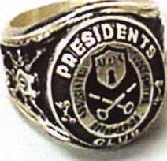

How can I join the President's Club?

You can earn a membership in this prestigious club by recruiting  
just 10 new members for ALOA.

*Any ALOA member may participate.

What do I get?

When you recruit 10 members, you receive a  
handsome blue blazer with a President's Club crest.  
For each additional five members you recruit, you  
receive a lapel pin with gold-filled numbers, indicating,  
your recruiting successes.

You also get the satisifaction of knowing that you are  
helping your association, helping your industry grow,  
and you are helping fellow locksmiths achieve success.

How do I get started?

Mail the form below to the ALOA office for a supply of  
applications (800) 532-ALOA or FAX (214) 827-1810.  
One President's Club credit is awarded for each new  
applicant. Credit is awarded only after the membership  
application is pproved. However, the credit will apply  
for the period in which the application is received.  
Failure to identify yourself as the sponsor on the applica-  
tion form at the time it is submitted to ALOA for process-  
ing will forfeit any credit.

|  |  |  |
| --- | --- | --- |
|  | Yes! 1 | want to join the ALOA Presidents Club. |
|  | Please rush me applications so 1 can start earning credit toward membership in the club! | |
| Name | | |
| Company | | |
| Address | | |
| City | State | Zip |

Mail this form to ALOA • 3003 Live Oak • Dallas, Texas 75204-6186

FEB I JAN JAN

upcoming events

|  |  |  |
| --- | --- | --- |
| UPCOMING PRP SITTINGS | | UPCOMING ACE CLASSES |
| 12/11/2003 | 8:00AM • Dallas, TX • ALOA | February 25-27 Galveston, TX |
|  | Hope Rodriguez 800/532-2562 X30 | Texas Locksmiths Association |
| 12/14/2003 | 9:00 AM • Fairborn, OH | 14 ACE Classes |
|  | Ohio Valley Chapter | Butch Titus, CRL |
|  | William M. Lockwood, CRL | 210/649-2166 |
|  | 937/775-2154 | March 12-13 Minneapolis, MN |
| 1/8/2004 | 8:00AM • Dallas, TX • ALOA | Minnesota Chapter of ALOA |
|  | Hope Rodriguez 800/532-2562 X30 | Dana Lee, CML |
| 2/8/2004 | TBD • Oklahoma City, OK | 612/968-4500 |

Oklahoma Master Locksmiths Association

Mike McGrew

918/333-9136

2/29/2004 10:00AM • Galveston, TX

Texas Locksmiths Association Butch Titus, CRL 210/649-2166

3/14/2004 9:00AM • Minneapolis, MN

Minnesota Chapter of ALOA Dana Lee, CML 612/968-4500

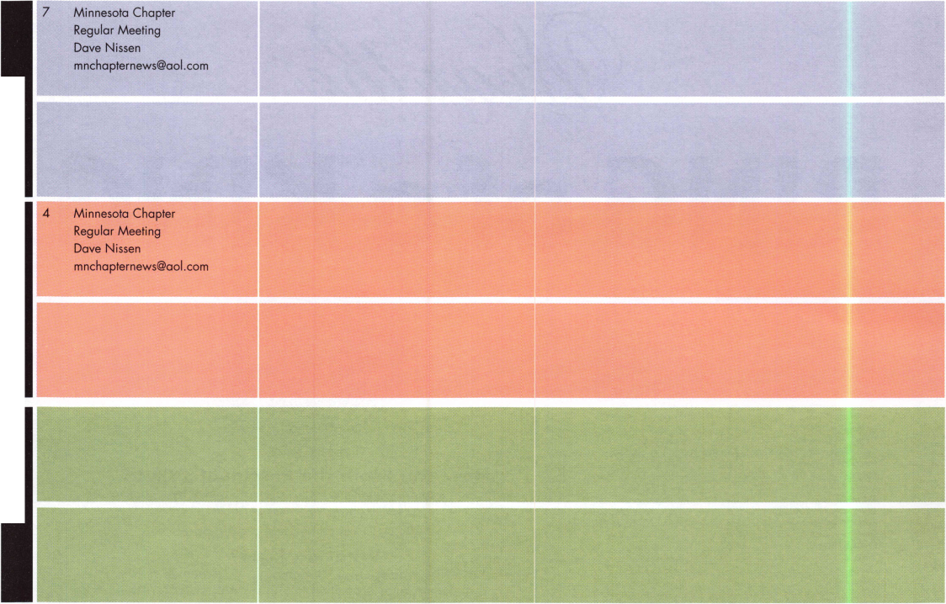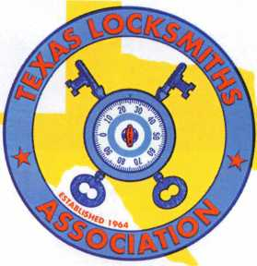

41ST ANNUM CONVENTION & TRADE SHOW  
IN THE HISTORIC MARKET DISTRICT ON GALVESTON ISLAND  
FERRUARV 24 - 29, 2004

AiOA AGE GLASSES

Wediesdav, February 25,2004:

Investigative locksmithing I Automotive Key Generation

Electronic Sate Lock Servicing & Troubleshooting Small Format 1C • P-38

Thursday, February 26,2004: investigative Locksmithing II Advanced Transponders

Combination Lock Servicing a Troubleshooting Large format 1C • P-39

Friday, February 27,2004: investigative Locksmithing III Remotes a Automotive Update Safe Deposit Locks Motorcycle Locksmithing • P-22 Basic Safe Penetration Tubular Key Locks • P-12

“P-#” indicates PRP certified classes

* FREE CUNICS
* FREE SEMINARS
* GENERAL MEMBERSHIP MEETING
* ELECTION & INSTALLATION

OF NEW OFFICERS

* PRODUCT EXHBIT
* SCHOLARSHIP RAFFLE
* BANQUET DINNER, CASI NO PARTY

FOR MORE INFORMATION CONTACT:

Batch Utils, Secretary • P.6 Bax 142 • Adkins. TX 78101 • 210-649-2166

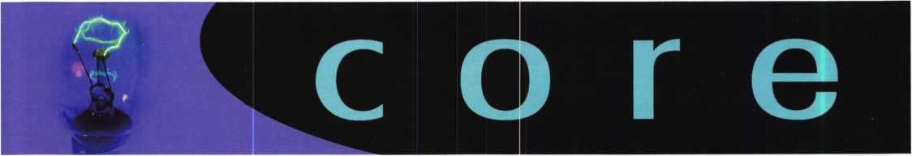

ALOA Fall Board Meeting at the Pacific Locksmith Conference

ALOA conducted its 2003 Fall Board of Directors meeting recently in Portland, OR. During their stay, the ALOA board attended a regional trade show and convention as guests at the Pacific Locksmith Conference (PLC). The ALOA Board completed their work agenda on schedule with great success. Newly elected ALOA president, Bill Young, CML, led the Board in far-ranging discussion and actions on a wide range of topics including public awareness, marketing, legislation, education, certification, and youth incentive programs. Plans were made to celebrate ALOA's 50th Anniversary in 2006. Young was the keynote speaker at the PLC Banquet. There, he spoke of ALOA's commitment to the members of the locksmith industry and his vision for ALOA's future. All members of the ALOA Board expressed thanks to the PLC for their gracious hospitality. The highly diverse makeup of the 19-member ALOA Board is quite representative of the makeup of the physical security industry, and includes man­ufacturers, distributors, members from Europe and Asia, and both big and small lock­smith businesses.

MEMBERSHIP RENEWAL DEAL!!

Starting in January 2004, all ALOA members who renew for the year will receive a $15 discount off ClearStar membership (currently $45). This includes new and renewal memberships with ClearStar. Application must be made through ClearStar: [www.security](http://www.security) @cIearstar.com

Long-time Employee Dies

Ellie Wooderson, former Comptroller for ALOA passed away on November 9, 2003 in her home. Ellie managed ALOA's finances for more than 17 years. She worked closely with the board, staff and membership. She retired in 1997 and moved back to her home state of Kansas, where she was living when she passed away. She will be missed by all who knew her. Services are pending.

|  |  |  |
| --- | --- | --- |
| NEW PRP | CERTIFICATIONS |  |
| DATE | NAME | LEVEL |
| 9/28/03 | Clayton Turner | CRL |
| 10/03 | Laura A. Miles | CRL |
| 10/03 | Calvin L. Pinson | CRL |
| 10/03 | Arthur J. Maddalena | CRL |
| 10/03 | Mark W. Fuller | CPL |
| 10/03 | John T. Bottoms | CRL |
| 10/03 | Ronald R. Smith | CPS |
| 10/03 | Daniel King | CPL |
| 10/17/03 | Paul L. King | CPL |
| 10/17/03 | John Mussel, Jr. | CPL |
| 10/17/03 | Michael W. Angelo | CRL |
| 10/17/03 | Brian M. Beard | CRL |
| 10/17/03 | Daniel M. Hyde | CRL |
| 10/26/03 | Michael T. Bruder | CRL |
| 10/26/03 | Steven Vanegas | CRL |
| 10/17/03 | Jeremy Kaminsky | CPS |
| 10/25/03 | Robert R. Cullum | CPL |
| 10/25/03 | John D. Vessels | CPL |
| 10/25/03 | Robert D. Auch | CRL |
| 10/25/03 | Sean M. Nixie | CRL |
| 10/25/03 | John J. Roman | CRL |
| 10/25/03 | George R. Gardner | CPS |
| 10/25/03 | Roger S. Wechter | CPS |
| 11/13/03 | David Been | CRL |
| 11/13/03 | Nicholas Pryor | CRL |

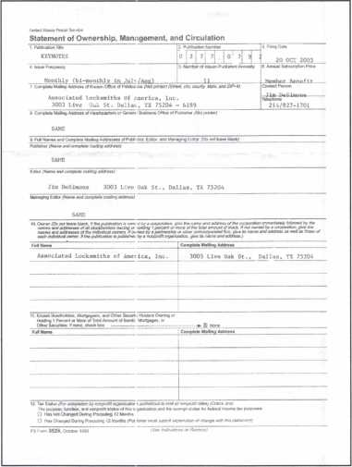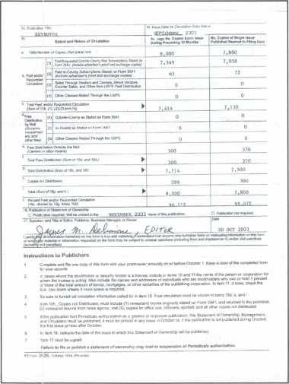

Ruailahle as single  
modules (one CD and  
guidebook) or the full  
set (three CDs and  
three guidebooks).

Seruer uersions are  
also auailable!

FUNDAMENTALS OF:

'oors *and Hardware*

*Self-Study* Course

nflisi myjiiiHi mrjmm

**Self-Study Course**

RLOR

SPECIRL

**Get the award-winning  
*Fundamentals of Architecture  
Doors and Hardu/are Self-Study  
Course* at a great price!**

fclALOA <(

The ultimate training tool for locksmiths... Now there is a complete in-house training  
program auailable! Order the **Fundamentals of architectural Doors and Hardware Self**

**Study Course** three CD/guidebook series.

To order, call (800)532-2562 or iouiLU.aloa.org.

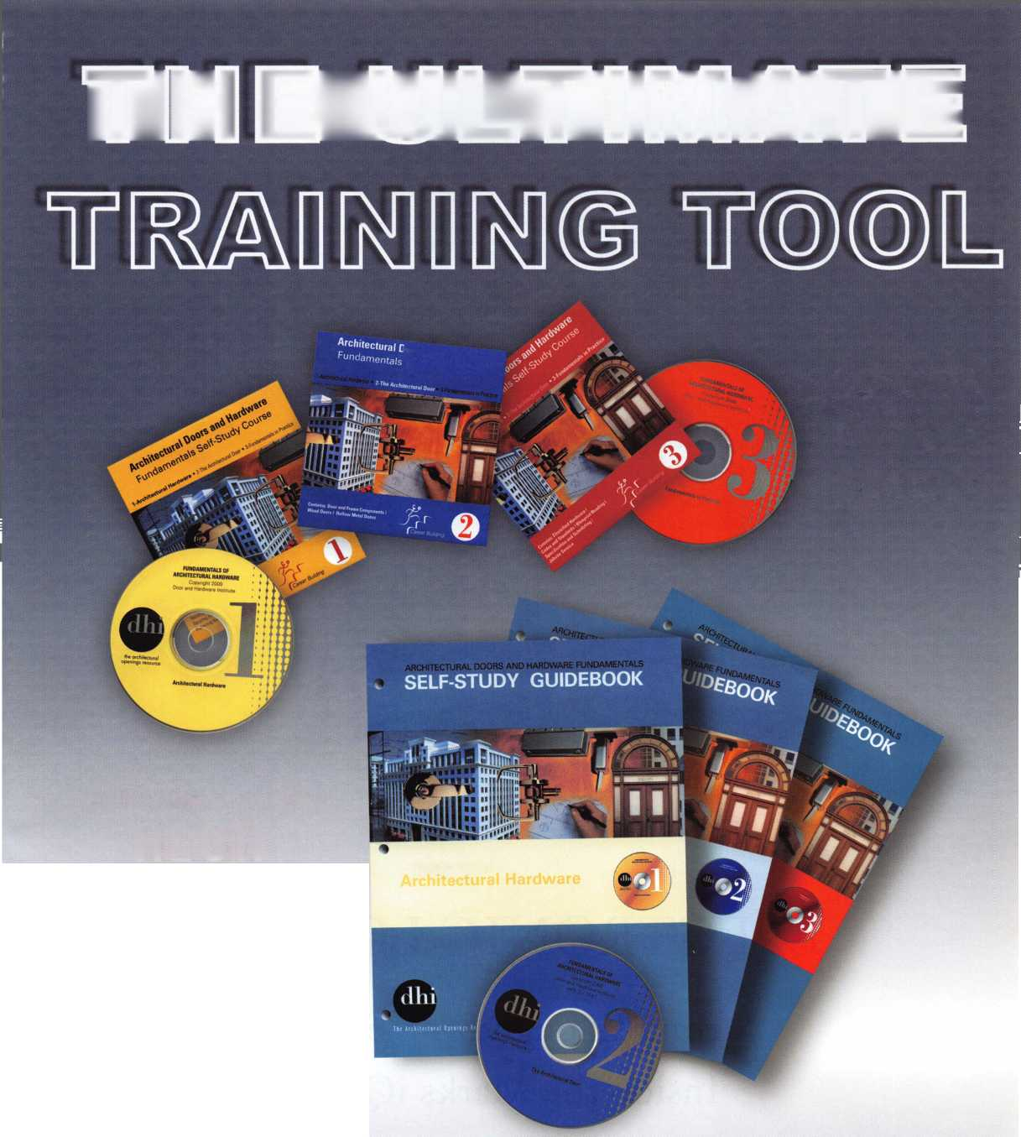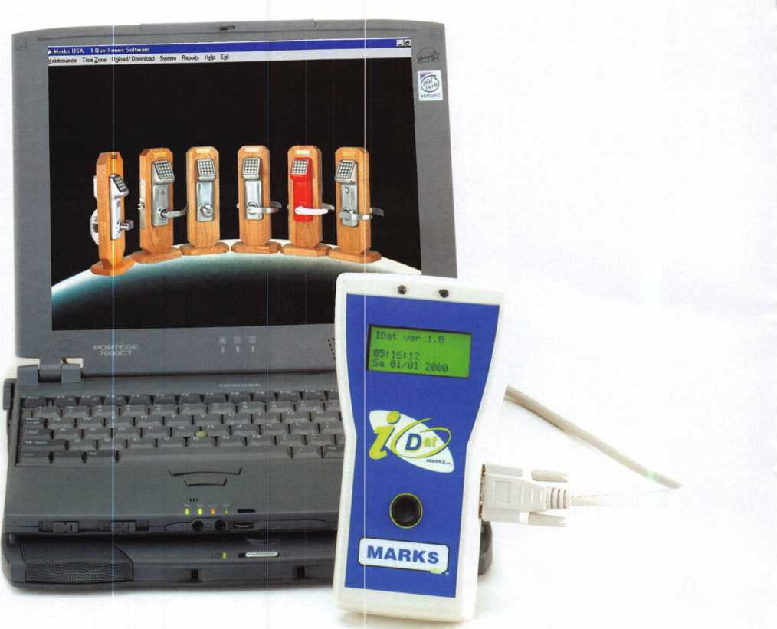

ELECTRONIC LOCKS:

Strong Enough for Sailors?  
Inside the Marks iQue

By Greg Perry, CML, CPS



Keynotes • December 2003

The ALOA show  
is always a great  
place to find new  
products and  
friends, as well as  
to get reacquaint-  
ed with some old  
ones. The Marks  
iQue, although  
not new, is a  
product I hadn’t  
taken a serious  
look at before  
the show We  
have a customer  
with mechanical  
pushbutton locks  
from a compet-  
ing company.

About every three to six months, they break the interior lever by pulling up on it, instead of pulling down. Most of the employees know not pull up, but the general public doesn’t. The Marks iQue is built around their standard Grade i mechanical lock with a solenoid to lock -- or perhaps a better way to say it is unlock — the outside lever. The solenoid engages the lever to oper­ate. When the door is locked, the outside lever is free to resist vandals. The inside lever can be pulled up or down. We also have a Navy base next to us, with sailors whose pri­mary mission is to kill people and break things. And trust me, these guys know how to break things. They’ve broken mechanical pushbut­ton locks by the hundreds. The only area of weakness or concern is the membrane keypad. It may not hold up to the abuses of sailors. I spoke with their representative, who had the factory send us a lock to try. We’re waiting for our customer to break an old lock, so we can install the Marks iQue.

I’ve installed the iQue on  
a mount to show the cus-  
tomer and test its opera-  
tion and difficulty with  
the installation. The lock  
installs like most cylin-  
drical locks with the  
addition of a .75-inch  
hole 6.5 inches up from  
the centerline of the  
2.125-inch crossbore.

This hole does not

match the loca-  
tion of the  
mechanical  
pushbutton  
lock we are  
replacing, so it will

require drilling a new hole.  
Although I like the lock and don’t  
see any reason to switch back, the  
location of the new hole means it  
would need to be patched if we ever  
wanted to go back to the old lock. It  
also makes the installation a little  
more time consuming. (A side note:

I wish the engineers would think of such things when designing a new lock.) The installation of the lock is similar to installing most cylindrical locksets.

After the holes are drilled, start by installing the latch. Next, insert the outside lock assembly into the cross­bore, making sure the latch is engaged properly Pass the cables through the upper hole. Next, remove the cover screw for the inside housing. Feed the cables through the upper hole of the interi­or backplate, lock washer and race­way nut. Loosely tighten the nut and install the two thru-bolt screws. Tighten the raceway nut and then the two thru-bolts. Tear the wrapper off the cables and connect the gray and red wires to the gray and red wires from the inner lock spindle.

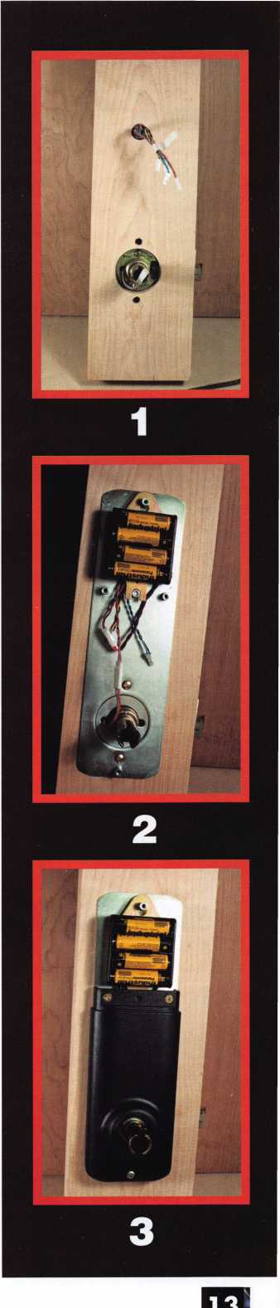

Keynotes • December 2003

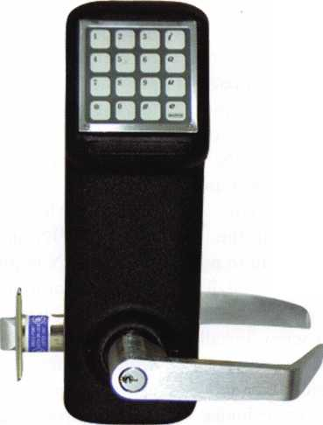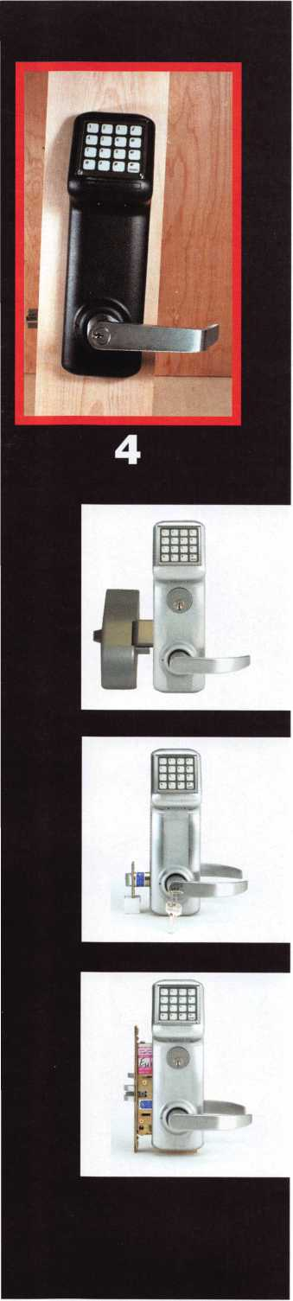

Connect the red and black cables from the raceway to the red and black battery box wires, then install the battery pack on the inner back- plate. There are a couple of extra pairs of wires for optional features, and a pair used for defaulting the lock back to the way it came from the factory These wires are left loose and will be tucked into the bottom cover. Next, use care to not pinch any of the cables and install the lower cover over the spindle; then install the lower screw. Install the battery cover and its screws. Finally, install the inside lever and the outside lever with the cylin der.

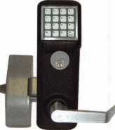

Once the lock  
is completely  
installed, the  
programming is  
next. The lock  
comes from the  
factory with a  
non-function-  
ing code. This  
means to use  
the lock, a new  
GGM code  
must be set.  
This is to pre-  
vent a user  
from installing  
the lock and  
“just using the  
factory code”  
as the operat-  
ing code. Once  
the new GGM  
code is set,  
other codes can  
be added and  
some other  
functions can  
be changed. All

the user codes must be the same length, as the GGM code and the GGM length can’t be changed once it is set - at least not without

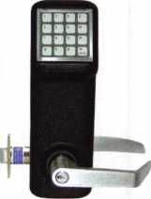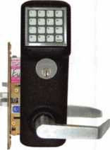

defaulting or performing a complete reset of the lock. The keypad has a total of 16 characters, i through o plus the * and # keys. It also has four additional keys; i, Q, u, and e. The * and # keys are used like enter keys. The balance of the keys can be used in the codes. One of the fea­tures of the lock allows the lock to be set for PIN only or UID (User ID) and PIN required. The UID adds three or four digits to the code entry. This Metro Series i lockset allows up to 32 users; other models offer more features and users. Each user is assigned a three or four-digit UID, a “Group Number” and a PIN. I was a little confused as I read the “User Codes” section. Why have dif­ferent group of numbers? As I read further, different groups allow you to change the authorization level or deny entry to different groups. For example, if you assigned users 101 and 102 to group 10, and users 103 and 104 to group 11, then you could deny entry to group 10 while allow­ing entry to group 11. The other thing I found confusing is 100 dif­ferent groups are available for 32 users. A couple of other nice fea­tures are the ability to require two different codes to open and manual passage mode.

The Marks iQue appears to be a well-made lock at a very competitive price. Marks has taken a proven Grade 1 mechanical lock, and added a 6-volt solenoid or motor, a keypad with some electronics and a battery pack, to create a self-contained access control system. The only problem I found with the lock is the programming instruction, I think they could be written a little more clearly. I’m a little concerned with the sailors and the membrane key­pad, but I think the lock is a good value for the customer.

Keynotes • December 2003

**During times of crisis, unity is key. Right now, when you join ALOA  
(or renew your membership), you will receive, free of charge,  
this patriotic decal for your shop or van, which serves as a  
special reminder to you and your customers that it takes  
a spirited effort to strengthen the ties that bind us.**

AIOA locksmiths M Secure America Ve

**Decal dimensions 87 2" x 57/**

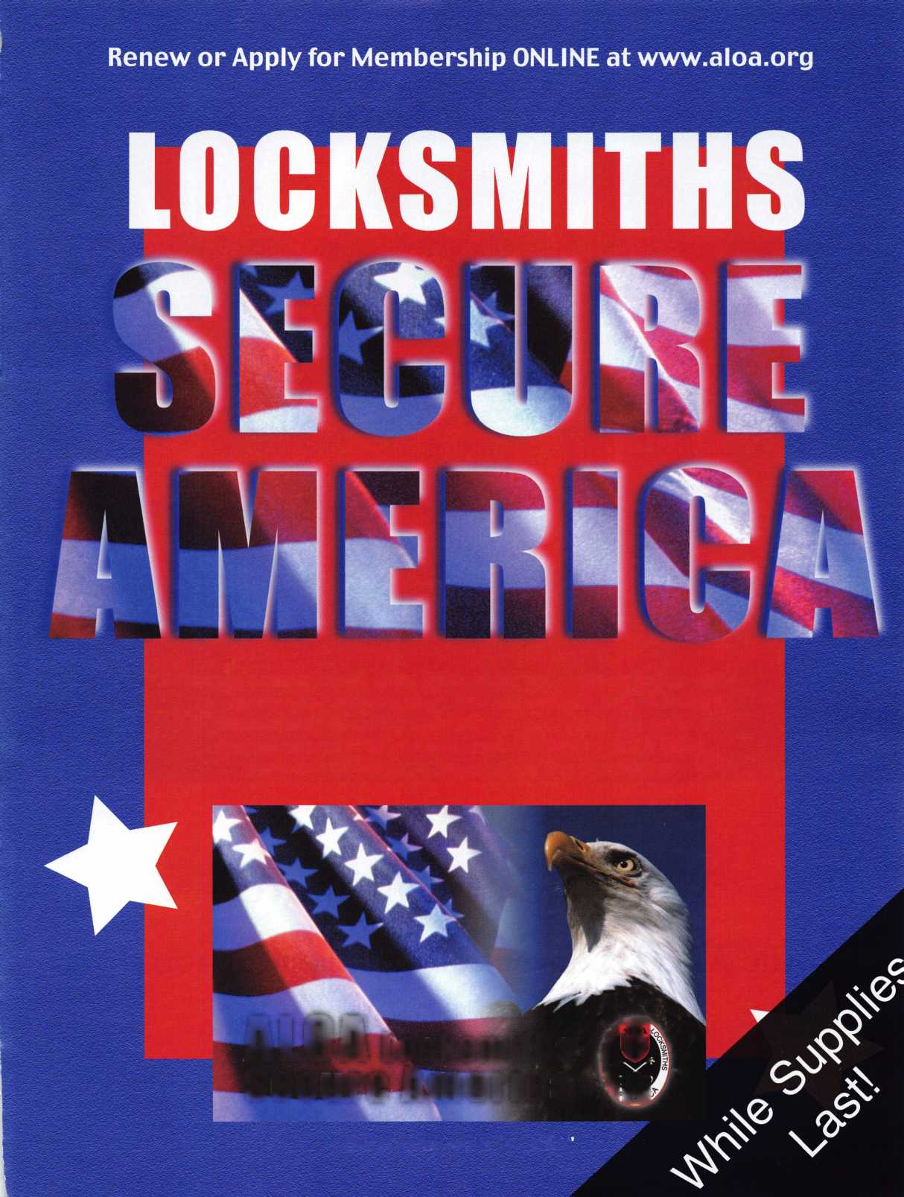

Welcome to Baltimore—

the ALOA Convention Location for 2004

By Claire L. Cohen

**6**

Keynotes • December 2003

This year the ALOA Convention will be held at the Baltimore Convention Center in Baltimore, MD, from July 18-25, 2004. If you are planning to come to Baltimore a day or two before the convention or stay after the convention, area attractions are plentiful.

Maryland’s diverse geography, natural resources, and world-class attractions make it the kind of place that appeals to every taste. Tourism is one of Maryland’s fastest growing industries. In 2001, more than 19.4 million people visited Maryland.

There are many sites to see just a short distance from the Baltimore Convention Center. Baltimore, nick­named “Charm City,” is the 13th largest city in the U.S. It is one of the most important cities on the East Coast, with a world port, government offices, major medical and educational institutions, and major tourist attractions. Since Baltimore’s redevelopment in the late 1970s, millions of people have come to see Baltimore’s Inner Harbor-- one of America’s oldest seaports -- and one of the world’s newest travel destinations.

Tourists delight in exploring the Inner Harbor, includ­ing the National Aquarium and Maryland Science Center. The U.S.S. Constellation was the last all-sail ship built by the United States Navy. Today, the his­toric vessel lies at anchor in Baltimore’s Inner Harbor, where visitors can tour the ship. Numerous art gal­leries and museums are all conveniently located in downtown Baltimore. The Baltimore Orioles baseball team stadium at Camden Yards is just a short distance from the Convention Center. Some outstanding restaurants are located in or near Baltimore’s Inner Harbor.

Maryland’s Central Region (including Baltimore) is where some of the most important events in state and national history took place, and where people are still making history So, if you’ve already seen the sites in downtown Baltimore, don’t overlook the attractions that lie within an hour’s drive of the Convention Center.

There is much to see and do in Central Maryland. The attractions vary from Maryland’s state historic capital (Annapolis), to its largest city (Baltimore), from waterfront villages and mill towns, to gently rolling hills of horse country, and the waters of the Chesapeake Bay. There is a variety of industry in this area, ranging from mining marble, granite and other stones, to harvesting fish and seafood.

About a 30-45 minute drive from Baltimore, is his­toric Annapolis. First settled in 1649, it is now Maryland’s state capital. Today, Annapolis has more 18th century buildings and houses than any other city in the U.S.

Thousands of visitors from all over the world pass through the State House in Annapolis. It is probably the best known building in the state. Visitors can watch Maryland’s government in action from visitor galleries in both the House and Senate Chambers.

Museums, located throughout Annapolis, can give an insight into what life was like centuries ago. In the city’s Council Chamber at City Hall, Annapolis’ early history comes to life. City Hall, and three of the homes of signers of the Declaration of Independence, are open for public tours.

The U.S. Naval Academy, established in 1845, contains exhibits to help tell the story of the Navy, from its earliest days to the present.

And don’t forget that Baltimore is only a 45-minute drive from our nation’s capitol, Washington D.C.

Also 45 minutes from Baltimore, are some other interesting sites. The National Cryptologic Museum and the Ft. Meade Museum display decoding devices and weapons used in the two world wars. The Historical Electronics Museum in Linthicum features items representing the evolution of electronics.

Feel like taking a short ride from the Baltimore Convention Center? Baltimore County is horse country. There are 149 thoroughbred horse farms located through its rolling countryside.



Keynotes • December 2003

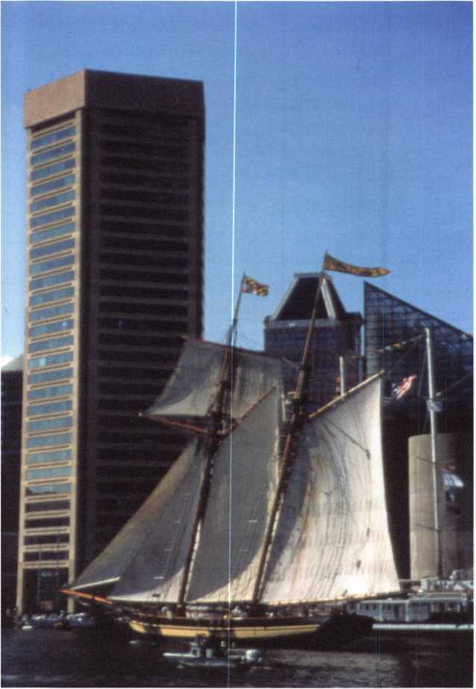

Pride of Baltimore II is a reproduction Baltimore Clipper and a sail­ing memorial to her predecessor, the original Pride. Commissioned in 1988, she sails the seas of the world as the Goodwill Ambassador from the State of Maryland and the Port of Baltimore.

More Baltimore history can be traced through exhibits in the Baltimore County Historical Society Museum in Cockeysville, the Catonsville Historical Society’s Townsend House and the Hampton National Historic Site in Towson. At the Fire Museum of Maryland in Lutherville, you can see vintage fire engines, and learn about the 1904 Great Fire of Baltimore. (This fire led to the stan­dardization of fire equipment in the United States.).

Visiting Carroll County, about a one-hour drive from Baltimore, you can get a closer look at farm and community life by visiting the Carroll County Farm Museum, the Union Mills Homestead and Grist Mill. Railroad history is found at the Western Maryland Railway Historical Society Museum in Union Bridge. This railroad was used by Lincoln on his way to deliver the Gettysburg Address.

One hour drive from Baltimore, Havre de Grace, located at the mouth of the Susquehanna River, has a long maritime his­tory. Here is one of the national’s oldest con­tinuously working lighthouses. There is also a decoy museum in Havre de Grace. In Monkton, Ladew Topiary Gardens is now open for all to see. It includes 15 garden rooms, and dozens of topiary figures, trimmed into different ornamental shapes.

The Aberdeen Proving Ground houses the U.S. Army Ordinance Museum, where visitors can see army weapons and combat vehicles.

The history of the people who built the rail­road can be found at the B&O Railroad Station Museum, located in Ellicott City—just a short 30-45 minute drive from Baltimore.

Make the most of your trip to the ALOA Convention. Plan to spend some time before or after the Convention to explore “The Best of Baltimore” and nearby Maryland attrac­tions. Have a great adventure!

**8**

Keynotes • December 2003



Proue You’re a Pro ’04

HLOH Rewards Its Members HGRINM

The RLOR Membership Campaign for 2004 features

more member benefits than me’ue euer offered

before. LUe’re stuffing members full of great gifts!!

If you reneui your commitment to your industry  
and help support RLOR, we will offer FREE mem-  
bership dues to RNY CURRENT MEMBER who  
recruits one new member on or before January  
1, 2004.

HLOH is excited about the uast legislatiue challenges that lie ahead,

and we re waiting for our members to let us after those groups that  
are aiming to legislate locksmiths out of business, one bad bill at a

time. lUe're ready to do our part for the prosperity of this industry.

Please help yourselues by doing your part this year. Proue you’re a pro by

sticking with HLOH in 2004. Vou will be rewarded for it many times ouer.

Note: The HLOH Board of Directors has enacted a $25 Legislatiue assessment to the regular HLOH dues for all actiue members in the USH (and territories) in 2004. If you Hue in the United States or its territories, you must pay the assessment to maintain your membership. The assessment will be payable during this year s dues billing, which mailed on Oct. 1, 2003. Hs directed specifically in writing by the HLOH Board, the proceeds from this assessment will be auailable for use ONLV in BLOB's legislatiue efforts.

**Rll members who reneui on or before January 1, 2004, will receiue:**

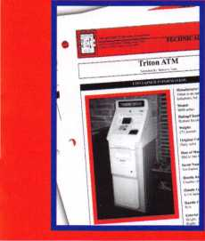

R complimentary set  
of 2 safe technical  
bulletins



Jkl-OJk'OH

fc-AUTtWORE, Ml?

get it... *together*

Up to $300 sailings  
on RLOR 2004  
Conuention  
registration

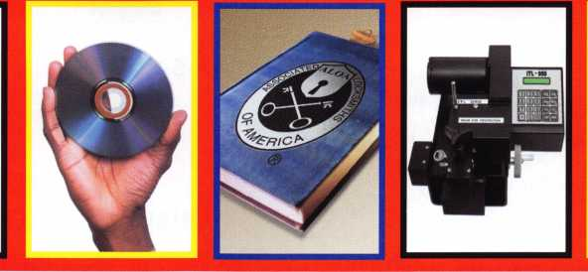

R complimentary  
copy of the RLOR  
Membership  
Directory (CD)

R $1 0 discount for any purchase from the RLOR Bookstore

Automatic entry into  
a drawing for a  
brand new ITL-950C  
key code machine

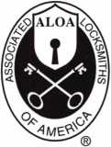

Rssociated Locksmiths of Rmerica

3003 Liue Oak Street • Dallas, Texas 75204-6186

800-532-RLOR (2562) • [www.aloa.org](http://www.aloa.org)



Automatic entry into  
a drawing for a free  
RLOR 2004  
Conuention Full  
Registration  
Package (including  
hotel)



Institutional Locksmithing:

Understanding Use and Occupancy Classification

By Dave Thielen, CML

Understanding Life Safety Codes is an important skill; we should all take pride in learning them. Although not the most glamorous or exciting subject, it is important to understand basic codes such as NFPA 80, NFPA ioi, etc. These codes are designed to protect occupants and provide a safe route out of a building in case of a fire, or other emergency. Codes should be adhered to, and taken serious­ly. Failure to do so may result in liabilities, expense, and serious embarrassment. In this article, we will explain some of the mystery of Use and Occupancy classification.

Since all buildings are not constructed for the same pur­pose, Fire and Building departments classify buildings into different categories or groups, depending on the relative hazard involved. Some groups are further divided into sub groups for easier clarification. According to the 2000 International Building Code, there are 10 different classifi-

Let’s take each group and look at a few examples to make things more clear.

Assembly Group

A-1



Assembly Group 1 includes Motion picture theaters and radio and television studios admitting an audience.

A-2



Assembly Group 2 includes restaurants, taverns, bars, night clubs and banquet halls.

A-3 IHri Assembly Group 3 includes churches,

ligSH libraries, auditoriums, museums, gymnasi­ums, art galleries, lecture hall, courtrooms iBBlp and arcades.

cations:

1. Assembly; Groups A-i, A-2, A-3, A-4, and A-5
2. Business: Group B
3. Educational: Group E.
4. Factory and Industrial: Groups F-i, and F-2
5. High Hazard: Groups H-i, H-2, H-3, H-4 and H-5.

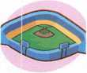

Assembly Group 4 includes Arenas, swimming pools and skating rinks.

Assembly Group 5 includes Stadiums, Grandstand and Bleachers.

1. Institutional: Groups I-i, 1-2, I-3, I-4.
2. Mercantile: Group M. BllSillCSS CjEOUp
3. Residential: Groups R-i, R-2, R-3, and R-4.
4. Storage: Groups S-i and S-2.
5. Utility and Miscellaneous; Group U



Includes Banks, laundries, post offices, print shops, professional services (attor­neys, dentists), car wash, outpatient clinics and educational above the 12th grade

Keynotes • December 2003

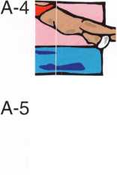

Educational Group

Institutional Group

E



Includes schools through the 12th grade and day care.

Factory and Industrial Group

F



Group 1 includes moderate hazard facto­ries, aircraft, appliances, automobiles, bakeries, beverages, carpets, clothing, electronics, food processing, furniture, machinery, millwork, paper products, shoes, textiles, tobacco, upholstery, wood­working, etc.

F-2

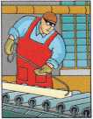

Group 2 includes low hazard factories, brick, ceramics, foundries, glass, gypsum, ice, etc.

1-1

1-2



Group 1 includes buildings housing more than 16 persons, needing 24-hour person­al care, group homes, drug and alcohol centers.

Group 2 includes buildings housing med­ical, surgical, nursing care on 24-hour bases of more than five persons, hospi­tals nursing homes.

1-3

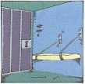

Group 3 includes buildings inhabited by more than five persons who are under restraint or security, prisons, jails, deten­tion centers.

1-4



Group 4 includes buildings occupied by persons who receive care for less than 24- hours, child care and adult care.

High Hazard Group

H-1



Group 1 includes buildings that pose a detonation hazard such as explosives.

H-2



Group 2 includes buildings that contain a hazard from accelerated burning such as flammable gasses, unstable material.

H-3



Group 3 includes buildings that readily support combustion, fireworks, aerosols, and flammable solids.

H-4

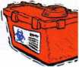

Group 4 includes buildings that contain materials that are health hazards, corrosives, and toxic materials.

H-5

a

3 Group 5 includes buildings that fabricate

Mercantile Group

M



Mercantile Group includes department stores, drug stores, markets, sales rooms, and retail and wholesale stores.

Residential Group

R-1



Group 1 includes hotels, motels and boarding houses.

R-2

HSSIf 1 Group 2 includes apartments, convents, BOlf Y I dormitories, and monasteries.

R-3



Group 3 includes residences where the occupants are permanent and not classified in R-1.

R-4



Group R-4 includes assisted living facili­ties including more than five, but not more than 16 occupants.

Keynotes • December 2003

Storage Group

s-i



Group 1 includes moderate-hazard storage, furniture, lumber, sugar, boots, grains, upholstery.

S-2



Group 2 includes low-hazard storage, cement, food products, glass, meats, metals, pottery and stoves.

Utility and Miscellaneous Group

u



Includes barns, carports, greenhouses, sheds, stables, private garages, towers.

Notes

An important note is that college and universities are not considered education, but fall into group B (busi­ness). These classifications are important to under­stand as they are referred to in many chapters of the code books. When, where, and how you can lock doors, depend on the use and occupancy classifica­tion. There are of course exceptions and additions to this list. For more clarification always refer to the AHJ, (authority having jurisdiction). I strongly recom­mend reading Chapter 3 of the International Building Code, and taking any classes on the subject that are available.

)MNILOCK Standalone Access Systems: since 1986 the most  
eliable and easiest to install solution for all applications...

More...Faster...Easier...Better!

* **PC-Based yet Standalone**
* **HID Prox or Mag Cards**
* **PocketPC Programmable**
* **2,000 Users per Door**
* **50,000 Audits per Door**
* **No Holes to Drill!**
* **No Wires to Run!**
* **No DTMs, laptops or plug-in  
  cables at the Door!**
* **Program in seconds, not  
  minutes like the others**
* **UL-Rated and Approved**
* **Built-in on-door Diagnostics**
* **Rugged Grade-1 Locksets  
  • Made in USA with PRIDE**

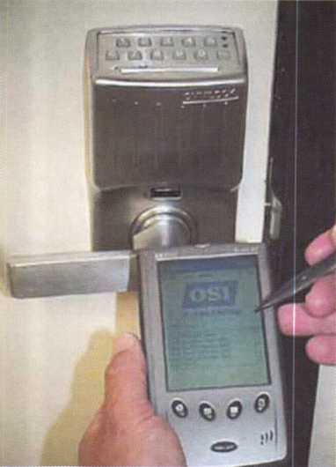

railable in Cylindrical, Mortise, Panic/Fire Exit  
irdware, Wall Mount System con guration  
ontrols electri ed hardware), or Quick Adapter  
dapts to **Existing** Schlage D Cylindrical locks).

**ir a**

ik "

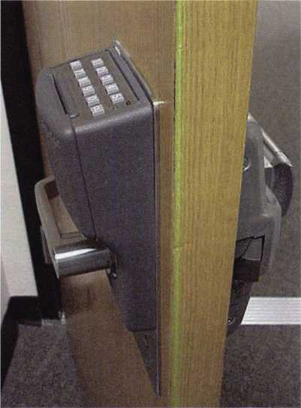

**OSI Security Devices** 1580 Jayken Way Chula Vista, CA 91911 phone: 619.628.1000 fax: 619.628.1001 **[www.omnilock.com](http://www.omnilock.com) [sales@omnilock.com](mailto:sales@omnilock.com)**



Keynotes • December 2003

FINGERPRINT RECOGNITION UP TO 50 USERS AUDIT TRAIL

INCLUDED PC SOFTWARE

ANNUAL AND WEEKLY TIMELOCK

TIMEDELAY

TWO LOCK MANAGEMENT WRONG TRY PENALTY DUAL OPENING THREE MANAGEMENT LEVELS

SWING BOLT, SPRING BOLT OR DEAD BOLT

AND MUCH MORE...

microtechniques sa

Route de Neuchatel 15a CH 2072 Saint-Blaise Switzerland

Phone +41 32 756 10 30 Fax +41 32 756 10 49 E-mail [sales@stbmicro.com](mailto:sales@stbmicro.com) [www.stbmicro.com](http://www.stbmicro.com)

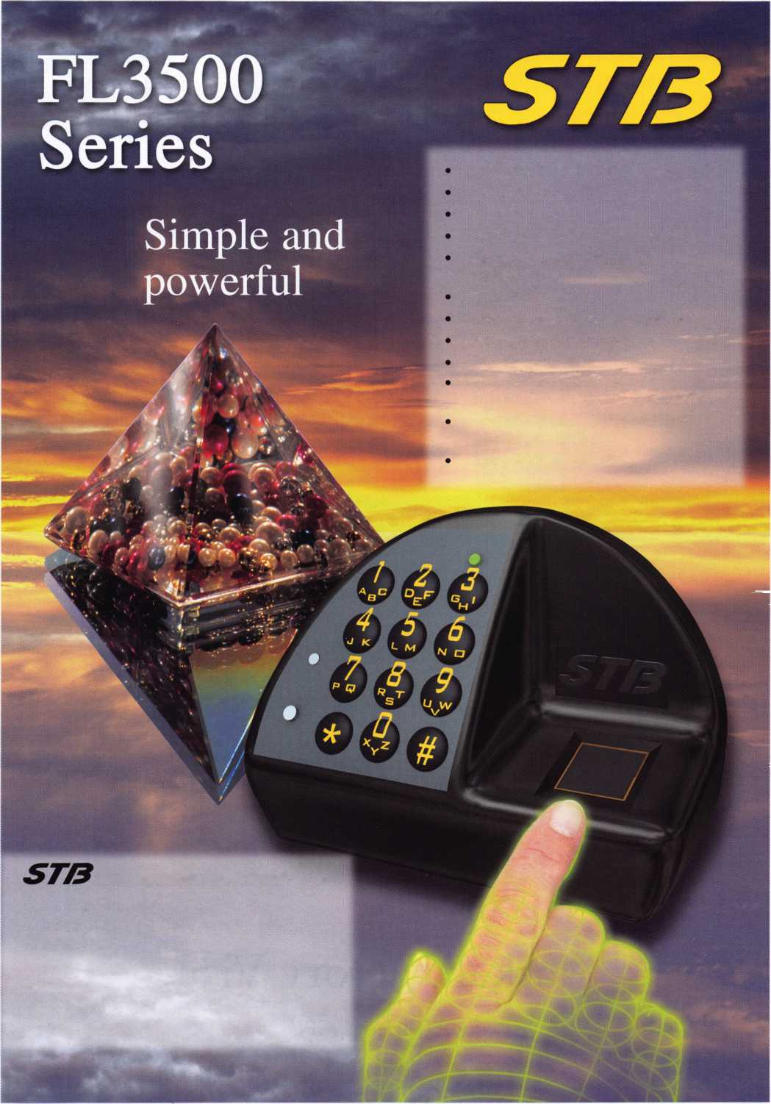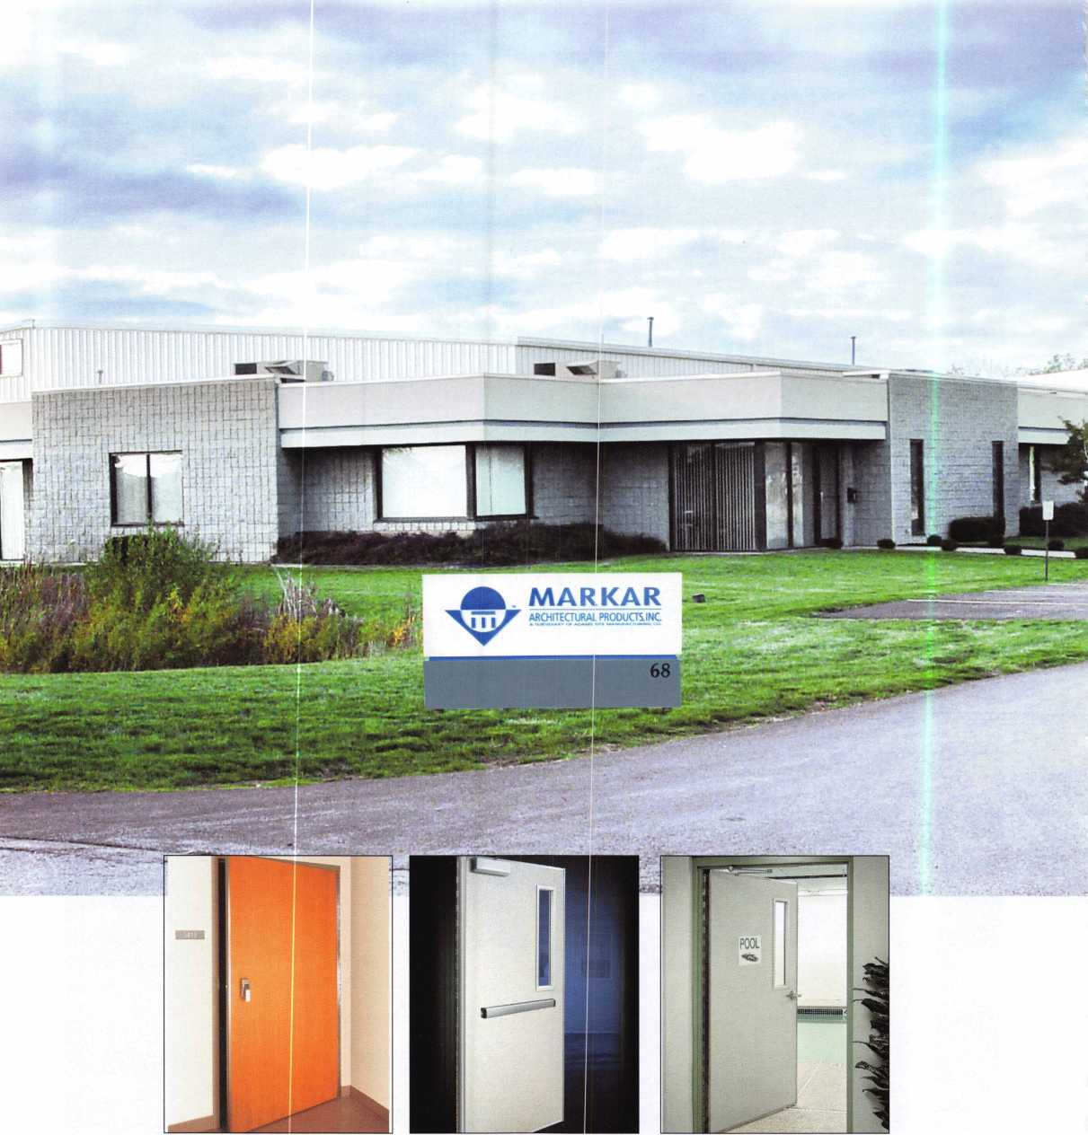

Markar Factory Visit

By Ray Iglesias, CPL

Keynotes • December 2003

Lately, I have been looking to expand my services and product line. To grow my locksmith business in Fort Lauderdale, FL, I knew that I needed to offer my cus­tomers more. But at the same time, I needed some­thing that could compliment my existing product lines. Lastly, I needed to use existing techs with mini­mal investment in tools and training, and of course, be profitable.

Sales and installation of doors seemed to be a good fit, but which ones? And maybe more importantly, how difficult would the adjustment be? I quickly ruled out inexpensive doors that dominated The Home Depot and Lowes residential market. The market for hollow metal doors for new construction has been dominated by contract hardware and contractors. Minimal profit margins for a tough market.

I seemed to be a quick dead end with my new prod­uct line. But this is when, with the help of Jose Salar, the local Markar Rep, I learned about another option. I got a phone call from a rep at the Markar factory in Buffalo, NY, who invited me on a factory tour. I was also invited to sit in on a class that covered FRP (fiberglass reinforced polyester) door construction, installation and Markar’s patented continuous hinge.

Markar, a 16-year-old company, was recently pur­chased (2001) by Adams Rite Co - a name we all know well. Adams Rite, with an infusion of money, new product ideas and automation, has put Markar on a winning track of door retrofits in the commercial and industrial arena. Our class began with breakfast and, where the Markar’s president, Kevin Hamilton, kicked off the day with humor and insightful anec­dotes. Entering the classroom, I could see that the tables were lined with various continuous hinges, door building materials, samples, and even Markar’s own Buffalo Wing Sauce. (Note: A stout constitution and appetite for Buffalo Wings is important for surviving a day with Kevin Hamilton and Markar.) At first I was a little uneasy, and I told Scott Mack, class instructor, this might be a little too complex for my locksmith techs. Scott just laughed and plunged into door con­struction, door product and door installation.

I must admit, I was amazed at the resilience of FRP Doors, and the adjustability of the door to the frame. With wide aluminum channel inner construction, the doors could support any manufacturer’s hardware and closures. As Scott ushered us along to the factory tour, I was beginning to think I had found my missing link. As we finished the tour, Scott said it was now our turn to hang one of his doors! I have never hung a door in less than four hours, but within 45 minutes, the door was hung and closing with a .125-inch reveal up and across the top of the door. I was impressed.

The class ended with questions and answers, along with an array of samples, which were distributed to help us in the selling of the products. At this point, Kevin Hamilton returned and as a special treat, whisked us all away to a tailgate party — and a Buffalo Bills football game! I kept it a secret that Pm devout Dolphins fan from South Florida. Instead, I ate my wings and enjoyed some great camaraderie with the Markar family.

What I liked about Markar’s FRP doors was their solid construction with wide top rails (6 inches) for mounting of door closures, a cross support of 4.5 inches to support any type of panic or lock prep.

That makes them both strong and simple. Also, the adjustable edge rail to fine tune fits in frames that are not square went well with the Adjusta Stud (patent pending), which made any door opening easy to fit with the turn of the Adjusta Stud Screw.

The factory has an eagerness to help prep doors for any type of hardware, or application. All doors meet or pass the Dade County Hurricane Code (the coun­try’s toughest test). Also available is a door with a three-hour fire rating. Light kits and louvers are avail­able, and aside from their six basic colors, they will do custom color at a small up-charge.

The only draw back is the six-week lead time, but this may shorten as they expand into automation. If you want to learn more about Markar doors and other products, check out their web page at [www.markar.com](http://www.markar.com). There, you can find a 16-minute installation video (downloadable). Or just call the factory at 800/866-1688. It could open a new door of profits for you.



Keynotes • December 2003

Cycle Chronicles, Part 2:  
The Polaris ATV

By Raymond D’Adamo, CML

Keynotes • December 2003

ecently, the owner of a 2000 Polaris 500 four-wheel  
ATV called to ask what it would cost to have a key  
made for the ignition switch, which is the only lock  
on the vehicle. I explained the costs based on his par-

ticipation. First, the cost for us to dedicate a field technician to  
fit the key where the vehicle sat, next if the entire vehicle was  
brought to us and finally if the ignition switch only was brought  
to us. He asked why there was no difference in the cost whether  
he brought in just the switch or the entire vehicle, and I said Fd  
show him why when we serviced the vehicle. He said he lived  
alone and probably did not have the strength to push it up a pair  
of ramps and into his pickup, so he decided to remove the  
switch and bring it in. Then he asked me how to remove it.

I paused for a moment. Based on previous experience, I had a general (more like a vague) idea of how to go about the disassem­bly process. Unfortunately, I had no specifics for a 2000 model, or for that matter, any other Polaris year model. That’s because, usually, it is not necessary to remove the switch housing when fitting a key So, I gave him a general idea of what to do, and leaving him with that, I hung up the phone.

About an hour later, he called back very frustrated. He said his frustration wasn’t my fault. He was just disappointed in his inability to remove the switch. He asked if I had any additional tips. I asked him to hold on and hit the hold button on the phone. I sat there for a moment, wondering what else I could say to help him. Past experience taught me that most Polaris ATV ignition cylinder plugs can be removed by inserting a probe through the keyhole, depressing the retainer disc at the back of the plug and tugging on the plug until it came out the front of the switch housing. Unfortunately, that process doesn’t help cus­tomers in this situation. Then I thought to myself, “We’re not busy right now and it’s a beautiful day. Why don’t I grab my camera, take it out there, and when I’m done, I’ll know exactly what to do and how to explain it. I returned to the line and arranged to remove the ignition lock at his place, and for me to take some pictures and notes. Then with my camera in hand,

I headed out to his place.

Berthoud, CO, is a small town just outside our regular service area. Main Street is lined with 19th century homes, antique stores, cozy cafes and canopies of skyscraper cottonwoods.

My destination took me up a side street and down an alley lead-



Keynotes • December 2003

**2**

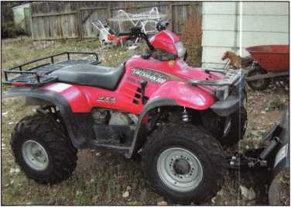

Photo 1

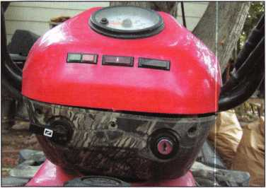

Photo 2

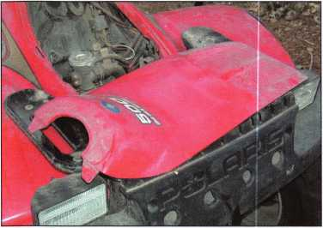

Photo 3

ing into the customer ’s back yard. There it sat (Photo i), and it hadn’t moved since it was used last winter during the first ioo-year snow storm I had ever experienced. We went right to work, but before we started disassembling, I tried to determine what had happened before I arrived.

As seen in photo 2, because the switch was mounted from inside the console, the customer removed the three screws at the rear of the console, thinking the front of the console halves just clipped to the headlight. That not being the case, he then could not deter­mine how to completely separate the console halves without breaking something. I removed the cowling in front of the console (Photo 3), which was secured with screws at the front end, and which just tabbed in under the front of the console at the rear end. Then we discovered console screws installed from beneath the front of the lower console half, which were hidden by the cowling. After removing these screws, separating the console halves (as seen in photo 4), and removing the top half exposed the switch and wiring harness. Next, we unscrewed the plastic bezel nut securing the switch in place and (photo 5) disconnected the switch from the vehicle’s electrical harness. As with other Polaris ATV switches of the period, it did not have a key code stamped into it. Though I could have fit the key with the switch housing in place, while it was removed I took the opportunity to take some pictures of the plug removal process, seen in photos 6 through 9. The last disc in the plug seen in photo 9 is the retainer disc. The only thing left to do was fit the key.

The Polaris ATVs of this period utilize a key system, which is a dead ringer for the five-position, three-step system found on Yamahas of the late 1970s and early 1980s. Going on that premise and using a common Ilco YH47 key blank typically for Yamaha

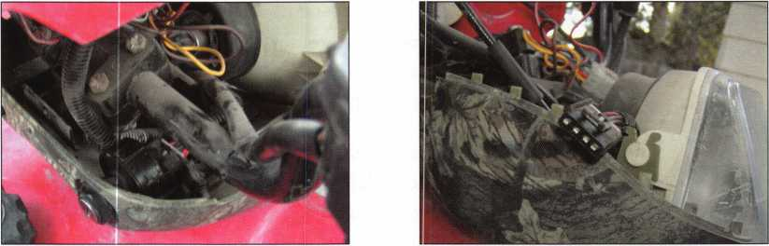

Photo 4 Photo 5

Keynotes • December 2003

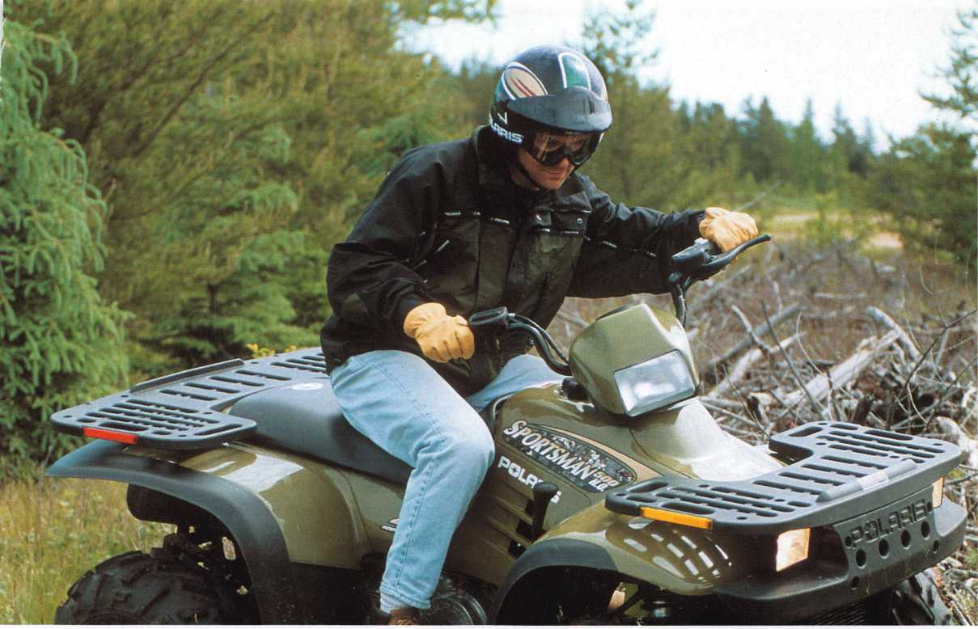

|  |  |
| --- | --- |
|  |  |
| Photo 6 | Photo 7 |
|  |  |
| Photo 8 | Photo 9 |

...before we started disas­sembling,

I tried to determine what had happened before I arrived.

Keynotes • December 2003

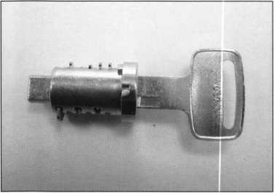

Photo 10

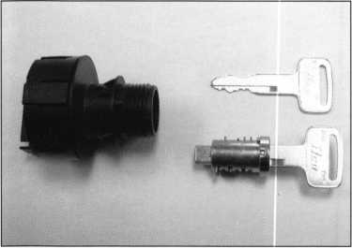

Photo 11

(which perfectly fit the Polaris plug’s requirements), I decoded the discs. As shown in photo io, the cuts from bow to tip were deter­mined to be 33213. Then, using the HPC MC81 code card and the HPC 1200CM code machine, the key was fit; the finished key can be seen in photo 11. When it was time to re-assemble everything, we just reversed the disassembly process.

As luck would have it, a week or so later, the customer called to say he found his original key, but that it was different from the one I made. I asked if he could stop by with it when he had a chance, so I could get a look at it. He did, and photo 12 shows that though the cuts on both keys are exactly the same, the key blank I used is flat, while his original is corrugated. This indicated to me that the ignition switch plug broaching is not very discreet. Now that I had an original key with a key code on it in my hand, I went through the various series of published Yamaha key codes, just for grins. Curiously, there exists a noticeable gap in Yamaha key codes, namely 1801-2610. This Polaris ATV’s key code, 2362, falls within the range of this gap. Could this gap in the Yamaha codes be the unpublished Polaris ATV code series? Only more research will reveal the answer.

And just like that, jour friendly ALOA Cycle Chronicles author had taken the time and initiative to discover the yet undiscovered, lifted the veil of ignorance and uncertainty, intensified our curiosi­ty and empowered us all to respond to our customers’ needs in a more confident and professional manner.

Whew. See you next time for another installment of Cycle Chronicles.

Photo 12



Keynotes • December 2003

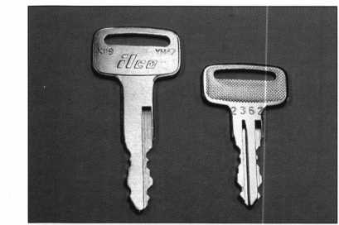

**Get What's  
Coming To You**

**ALOA continues to provide you with this and other great benefits and services!**

■ uulL)ld m cl)dbdb

**UlKjSJChj jmzrtr** T™ CD c3(^CD

Need mformahon in a hurry?

Use ALOA’s Fax On Demand service.

Just call 310-575-5074 and receive:

1. ALOA Index of Documents
2. Becoming a Locksmith (Ipg)
3. Locksmith Career Summary (3pg)
4. Locksmith School List (2pg)
5. ACE Class Schedule (8pg)
6. Certification lnformation(3pg)
7. PRP Category List (Ipg)
8. ALOA Membership Application(2pg)
9. ALOA List of Benefits (Ipg)
10. Scholarship Application Form (Ipg)
11. ALOA Video Library Order Form (Ipg)
12. ALOA Membership Items Order Form

(ipg)

1. Safe & Vault Technicians Association  
   Member Application/Subscription Form

(2pg)

1. ALOA Chapter Roster (3pg)
2. Legislative Action Network (2pg)
3. Legislative Action Network Newsletters

(ipg)

1. Various State Laws (lOpg)
2. Industry Position Pager (Ipg)
3. Current Legislative Action Network  
   Newsletters (Ipg)
4. Board of Directors Nomination  
   Form (2pg)
5. ALOA Convention Registration
6. ALOA Board Expense Reimbursement &  
   Request Form

310-575-5074



SAFE CORPORATION

Viking Stainless

Fire & Burglary Protection  
State of the Art Composite Fill

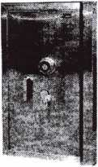

Strong • Functional • Attractive

Available in 10 sizes  
to Fit Every Need

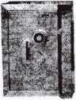

See us at [www.a-bsafecorp.com](http://www.a-bsafecorp.com)

1*-*800*-*253-1267

Fax 856-863-1208

CALL FOR YOUR CATALOG TODAY

Advertise with Weatherproof Safety Labels!

Lockout your  
competition

by placing your  
calling card on  
every door you  
service! Keep

your name in front  
of every customer  
with these Durable,  
Affordable Labels  
Call & Order Today  
1-800-355-6322

(Actual Label Size 1 1/2x4 1/2)

Professional Business Products

ALOA Associate Member

Check out our competitive prices on Invoices with two color ALOA  
logo, Repair Tags/Claim Checks, Business Cards, Door Hangers,  
Shirts, Hats, Pens, Key Tags, Magnets.

[www.professionalbusinessproducts.com](http://www.professionalbusinessproducts.com)

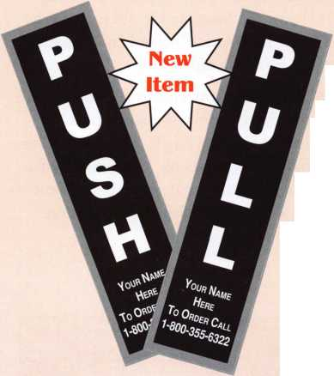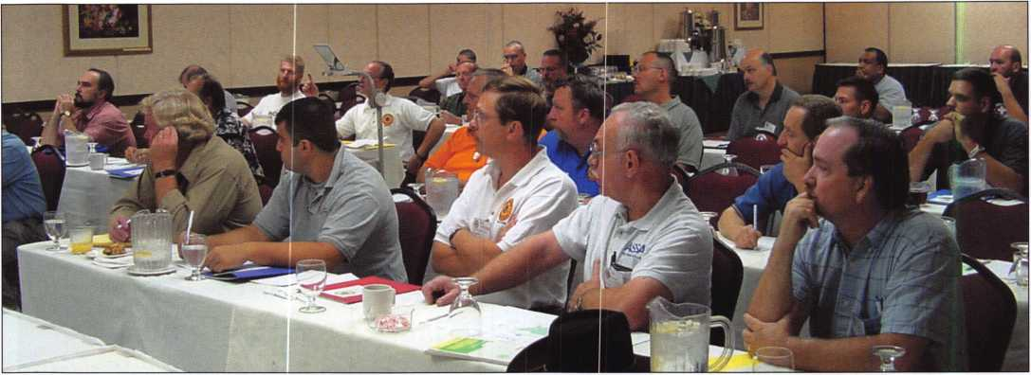

“We Didn’t Want the Classes to End!”

By Claire L. Cohen

The classes were so interesting that “we didn’t want the classes to end.” This was the opinion of many attending this year’s International Association of Investigative Locksmiths (IAIL) Convention.

IAIL recently held their second annual at the end of August, at the Wyndham Hotel in Mt. Laurel, NJ. A loca­tion near the airport was chosen, as members attending came from all over the world. Some 52 members from the United States, Australia, Denmark, England and Canada arrived for three and a half days of learning.

Convenient for attendees, all of the classes and meals were held at the same hotel. The convention registration fee included continental breakfast and lunch. These were times to talk to fellow members and exchange valuable informa­tion, tips and techniques. Evenings gave members a time to gather in small groups and discuss subjects of common interest.

Many participants pre-registered for the classes, while some made their course decisions on-site. The classes ranged in length from two to four hours, or full day. Some of the classes, scheduled to end at 5 p.m., had such enthusiastic students and teachers, and were so interesting, no one wanted to finish at the appointed time. Students and teach­ers decided to stay a little longer to learn more!

All classes were taught by IAIL members, with the excep­tion of one, in which the instructor was an attorney.

Herbert Miller taught a Forensic Photography class. The class included a comparison of digital and film photography for use as court evidence. The use of proper lighting was discussed, including the effects of lighting for effective evi­dence. Also a part of the class was the use of photo logs and investigative photography reports. The instructor emphasized that when doing any forensic lock work, pho­tography was an important tool.

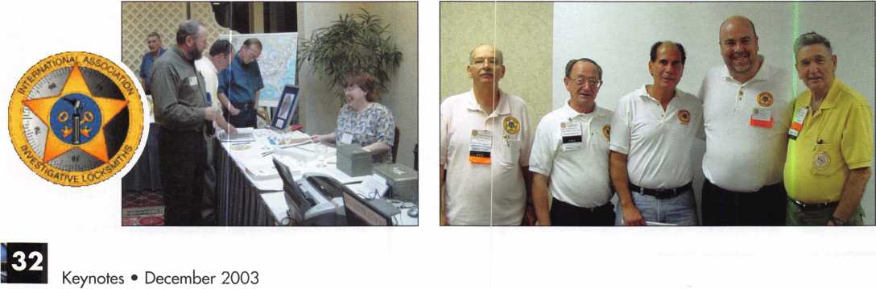

Investigative Locksmithing I, II and III were popular class­es at the convention. Instructors Don Shiles RL, CFL, and Jim Bickers started with a brief introduction and history of forensics. Photographs and slides of various locks, pins and wafers, which had been picked or subjected to impressing, were shown. A discussion of Investigative/Forensic lock­smith tools of the trade followed. Other topics included the standards for forensic locksmiths and Code of Ethics.

More in-depth work included hands-on working with basic tools. Students viewed locks and examined marks made by picks, or impressioning. A discussion of court testimony (with appropriate terminology), as well as insurance termi­nology, was covered.

A mock trial was conducted by John Truempy, as students participated as expert witnesses after being qualified to testify. Instruction was given in qualification as an expert witness. Advanced report writing was part of this class. Discussion included preparing for a trial and building a business as a forensic locksmith.

The history of metals was included in Bruce Summer CFEs Introduction to Basic Metallurgy and Plastics. Common materials used in the construction of various types of auto­motive, residential and commercial locks were discussed. Basic terminology was covered in this class.

IAIEs president, Don Shiles, RL, CFL, taught an interest­ing bypass class. This seminar included some of the most common bypass techniques used to illegally enter a facility. This hands-on class used various padlocks and door hard­ware to demonstrate methods of defeating locks. There was also a discussion of how tools used to defeat these locks were manufactured.

How do you write a Curriculum Vitae — a summary of one’s education, professional history and job qualifications for a prospective employer? This was the topic of another class at the convention, which was taught by Gordon Graber, an attorney from the Sullivan & Graber Law Firm. It was explained how important this document could be in estab­lishing validity of a forensic locksmith in a court of law. Attorney questioning under oath was discussed. The sub­ject of impartiality was reviewed.

An article in the New York

Times newspaper  
regarding the  
decoding of mas-  
ter key systems was  
the discussed in the

Decoding Master Key  
Systems class, taught  
by John Truempy. The

class covered both meth-  
ods of decoding, and key  
pattern analysis.

Ken Vitty, CRL, CFL, CFI,

conducted an auto theft and

arson class. Included in this class was information on meth-  
ods used in auto theft and major groups who are responsi-  
ble for many of the thefts. Methods of attacks on ignitions,  
as well as a discussion on transponders and VATS were cov-  
ered. Also a topic at this class was the role of the forensic  
locksmith in missing auto cases. Automobile arson debris  
identification was a part of this class, including a discussion  
of auto vehicle fire causes — mechanical, electrical or arson.

There are currently 35 Certified Forensic Locksmiths (CFLs) in the world. The CFL examination was given at the convention, where nine members qualified through testing, oral interview and background investigation. Many members are taking classes throughout the year, offered in conjunction with other locksmith organizations, in order to prepare for this examination.

There were many classes offered this year, with only three and a half days of the show. Members are eager to sign up for classes that they were unable to take this year, and look forward to additional interesting classes next year. The con­vention date has already been scheduled for June 10-13 in Jessup, MD (just a short distance for Baltimore/Washington International Airport). For more information on the I AIL organization and its convention, visit their web site at [www.iail.org](http://www.iail.org), or write to them at: 1507 Whitmarsh Circle, Severn, Maryland 21144.

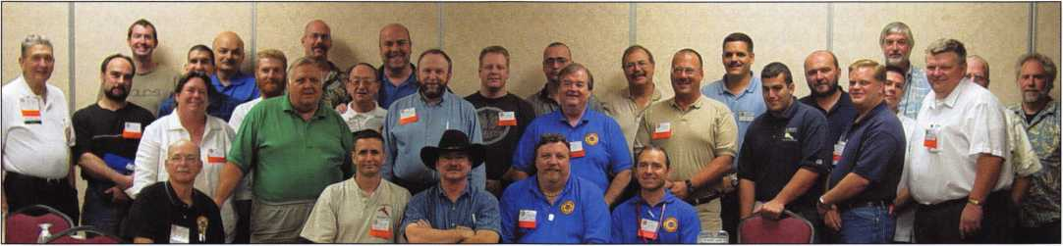

Keynotes • December 2003

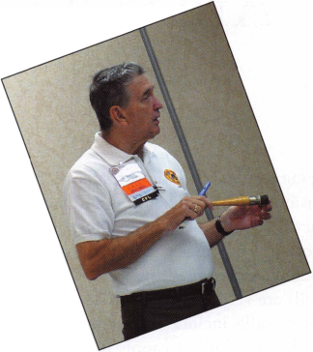

Are you using “Miraculous Pricing?”

By: Richard L. Dyer, CRL, CPS

Being successful, and profitable, is very important to most business owners. The ideas and methods used to achieve this vary from one business to another. There is no, one, correct method for being successful and profitable. Being successful is tough because of all the variables involved. Your individual skills are very important in developing a successful business. These skills include the technical skills necessary to do the work. The ability to apply technical skills only makes up one aspect of being, or at least having the chance to be, successful. Entrepreneurial and managerial skills are also extremely important. Without entrepreneurial spirit and a basic ability to manage time, multiple projects, and possibly employees, chances of success are limited. Additionally your market and customer base play very important roles in the success of any business. A good economy and a little good luck won’t hurt. Profitability relies on the skills above, good business sense, and an understanding of business practices; this includes how to price your products and services. Failing in this area will, at best, cause cash flow problems and, at worst, cause a business to fail. Over the years I have seen many businesses close their doors simply because they did not know the value of their products and services. Knowing the value of your products and services, and knowing what you want and expect from your business, will set the tone and direction of your business.

There are those that keep their labor rates extremely low, sometimes unreasonably low, to draw business away from oth­ers. It seems that some believe that because mass merchandis­ers can maintain low prices for their customers and draw busi­ness from others that they can do the same by lowering their prices. This is because those that look at pricing this way do not understand mass merchandising. Mass merchandisers don’t just lower prices they also lower their expenses enabling them to offer lower prices to their customers. Techniques utilizing special inventory controls, special buying programs, and other processes allow them to keep expenses low thus passing the benefits on to customers. They do not just lower prices to stay lower than the rest. Keep in mind that expenses must be cov­ered to stay in business. If prices are kept so low that a profit is negligible something must give, and that is usually quality. Others are keeping their rates low in fear. Fear that they will not get business if they raise their prices and that the only way to be profitable is with what I call “miraculous pricing.”

Pricing set so low that it will be a “miracle” if they make a profit. Most of these businesses will fail, either through burnout or bankruptcy. Usually in this case the business owner is working hard to keep cash coming in to the business, many times working more hours than they would if they had used a different method of pricing. Then there is the owner setting

low rates out of ignorance. Many times this is the new busi­ness owner. This group does not know what they want or need, and set their rates by guessing, or following the trends of others. By following the trends of the business owner afraid to raise prices, or the individual that sets pricing artificially low, this owner is courting disaster. This practice can run a busi­ness into the ground just as fast as the others.

I personally do not know of any business owner that created their business just to fail. But I do know those that have failed. Usually this was because they could not keep a cus­tomer base that would support them. While there is a chance that being the lowest priced business can initially bring in cus­tomers the chance that you can keep that customer long term is tenuous at best. Look at it this way, if that customer came to your business simply because you offered the lowest price, what would they do it someone cheaper came along? From my experience this kind of customer will bolt as soon as they find someone cheaper. From a price standpoint consumer loy­alty is rare. Customer service and quality builds loyalty, not low prices. Earlier I wrote that knowing what you want and expect out of your business sets the tone of the business. It is some­times too easy to get into business today. In our industry, in most parts of the country, one only has to say they are in busi­ness. Some areas may require tax licenses, but usually not more than that and no area that I know of requires any business education or experience. I have heard frequently over the years comments of how someone opened their own business because they were tired of making the boss rich, while they stayed poor. While I am sure there may be some truth to that feeling out there somewhere, most of the time this type of comment is nothing more than a failure to understand how a business works. Getting into business using these wants and expectations is wrong. Starting a business with this belief is just looking for failure.

Pricing your products and services has a direct impact on the level of customer service you can offer. As I mentioned earlier, there are businesses that set their prices so low that it is a mir­acle a profit is made. I don’t know any business owner or man­ager that is not out to make a profit. If pricing is not devel­oped to allow for a reasonable profit, then something else must be adjusted. Too many times this adjustment is in the quality of materials used and offered, and the quality of cus­tomer service. Customer service is a concept frequently mis­understood. Customer service is not just cutting a key or installing a lock with a smile. It is not simply making the cus­tomer happy with what is being done at the time. Customer service includes the type of services you can offer to a cus-



Keynotes • December 2003

tomer and the level of skill that you have to offer these servic­es. In my experience most customers, especially commercial customers, are looking for full service. Using our customers as an example, with very few exceptions, they want someone that can service their physical security needs, electronic security needs such as access control and CCTV, as well as their safe or vault requirements. This means education. I am constantly told about how expensive education is for the small business.

It seems that getting good education for some is considered a burden. Education, while seeming expensive, is necessary for the growth, and success, of any company. I also hear that equipment is too expensive to purchase, again I answer that some new equipment, or even equipment maintenance or replacement, is necessary for growth and success. Having the right type of quality equipment can make you money. Recently I damaged my favorite borescope while opening a safe I shipped it out for repair and that evening I received an emer­gency call to open another safe. With my primary scope out for repair I had to rely on a lower quality safe we have in the shop. The experience of using that scope reminded me how important good equipment is to a professional. Using the lower quality scope cost me time. The optics were not as good as the other scope. The lower quality cost me time and made the job harder. Good equipment is not only an investment it is good business. In almost every case the individuals making these comments fall in one of the pricing categories above. Failure to develop adequate pricing techniques, and pricing plans, causes the small business owner more work and increas­es the potential for business failure.

One method available to determine pricing asks the business owner to determine their true expenses. These expenses include, but are not limited to, insurance, rent, vehicles, mate­rials, labor, taxes, professional fees, telephone, education, and anticipated profit. This is where you include your salary, replacement tools, and new equipment to stay current with technology and industry changes. This list is not complete and should be adjusted for each business. Notice that I mentioned professional fees, education, replacement tools, and new equipment. I don’t know how many shops I have visited where a 30 year old machine was being massaged to keep it working. Sometimes this is because the machine is specialized and has no replacement on the market. But usually this is because they had failed to plan for replacement by including this in their pricing figure. They simply cannot afford a replacement. Membership dues for trade associations such as the Associated Locksmiths of America, ALOA, or the costs associated with attending trade shows or conferences such as the annual ALOA convention and trade show need to be plugged in to this formula. Trade show and conventions are not too expen­sive. They help to build businesses. Other educational pro­grams should also be included, even those that are unknown at the time of the plan by simply inserting an anticipated or sci­entific guess of the cost of training. Even if the guess is too low it is closer than not planning. With this information, and knowing the number of productive hours available (billable

hours), an hourly rate for services can be determined. There are several sources to obtain the mathematical formulas used to develop an hourly labor rate using the information you have developed. Using this hourly rate to determine service rates, the owner, either through an established industry, or locally determined flat rate chart, can determine reasonable pricing for each service offered. Using this formula, quality is built into the equation. There are no surprises; costs and pricing are visible to the manager. Adjustments are made before quality is affected. Using this as a base line figure, pricing adjustments can be made as the situation demands.

Once you have determined what your hourly labor rate should be, apply it, don’t let it sit on the shelf because you see that you are higher that some other business. If you have figured your true expenses and determined them valid, stick with your figures. Remember there will always be others setting their prices in a manner that will ultimately hurt them, don’t let their practices hurt your business. I have found that in some cases your business may end up being the model copied by others. Make this method public, encourage its use by others, it will help your efforts in the process.

One thing you and others may find when making these calcu­lations are that your expenses are too high. Use this as a tool to further manage your business. Look at your expenses; are they excessive in some areas? Do you have too much invento­ry? Do you even know how much inventory you have or where it is stocked? What about inventory shrinkage? Is your advertising cost effective? Are you spending too much time on tasks that keep you from billable work? These and other questions can be answered as you do this review. So in addition to assisting you in developing your labor rate and pricing, this information will allow you to fine tune your busi­ness, again making it more profitable.

Pricing is one of the most important tasks required of a good business owner. Prices that are too low cause business failures, burnout, and can hurt the reputation of a business. Prices that are too low usually result in poor quality and support. A busi­ness that barely covers expenses cannot afford to also cover warranty work and hardware adjustments. When pricing is too low many times the work is done quickly with minimal, if any, quality control.

Most businesses have similar expenses. Some expenses are higher and some are lower, but all are usually within a common range. Usually this difference is in how the business advertises or in the type of facility used. Using the information above and knowing what your true expenses are, you can set a fair and reasonable price for your work. Fair and reasonable pric­ing, pricing that will allow for growth and comfort while being fair to your customers, will only help the reputation, and prof­itability, of your business. A business with a good reputation usually is a profitable business. A business with a good reputa­tion can grow and prosper, furthering the good efforts of the entrepreneur, creating peace of mind and personal satisfaction.



Keynotes • December 2003



By Eric Costley, CRL

As the season for excess creeps upon us, I’d like to rattle a few cages concerning gadgets and showmanship as an integral part of our profession. As a rule, our goal as locksmiths is to remain as professional as possible, providing timely service for a fair price. However, the public doesn’t always see it this way

I had just started my apprenticeship. I was eager to please and wet behind the ears. A call came in to go unlock a car about a block away, and the service charge at the time was a mere $18. I arrived at the vehicle, slid the appropriate tool between the glass and weather­stripping, and was inside and writing up the receipt in about 5 seconds. The customer went ballistic! EIGHTEEN DOLLARS FOR 5 SECONDS OF WORK? It was at this point that I first realized that some customers want a little show for their money. Hence, “The Dog and Pony Show.”

**36**

Keynotes • December 2003

Yes, I can frequently pick a lock or open a vehicle fast enough that if you sneeze, you’ll miss it. But let’s face it, not everyone wants to know that it is actually that easy to enter their car or home! Sure, it helps when you tell them that you’ve been doing it for over 20 years full time, but gauging the character of your cus­tomer ahead of time can sometimes save you a lot of grief when it actually comes to collecting your fee.

There’s a documentary on The Beatles that tracks their time spent in Hamburg, Germany, before they actually achieved their worldwide success. One of the comments was that the Germans wanted the bands to “Mach schau! Mach schau!” In English, that means “Make a show!” You see, it wasn’t enough that the best band in the world was there playing for little or nothing; the audience wanted a show! Get the point?

You can learn to spot these customers with a little practice. When in doubt? Make a show! Instead of the five-piece pick set that you keep in your hip pock­et, dig into the back of the van and pull out the 50- piece kit. You know, the one that folds out in six dif­ferent directions? Teah, lay it out carefully by the door, and inspect the lock with an infrared light before selecting the proper pick with fear and trepi­dation. (Try frowning, rubbing your chin, tapping at your lips with your forefinger, and other time-honored gestures of a man deep in thought.) If you do happen to pick the lock in less than five seconds, who’s to say it doesn’t take an additional two minutes to actually turn the tension wrench? Always appear busy, and a few beads of sweat never hurt.

Some of you, I’m sure, are ready to slap me silly for such deception. I agree. But at the same time, I also know that some of you would benefit from a wad of Silly Putty and a firecracker fuse when 10 people are standing over you while you try some dialing diagnos­tics on a safe lockout. Hey, if you can clear the build­ing and get down to business undisturbed ...

For those of you who have been in this business for a long time, you may remember the days when there were no standardized .05 or .03 pin kits, and the whole profession was shrouded in secrecy and mys­tery. To most of the public, it still is! For the most part, what we do is “magic” to the uninformed, and every magician knows that it helps to develop a little “patter” to distract the audience while you beguile

them. Explaining the mechanics of impressioning or picking not only informs your customer, but makes you look knowledgeable as well. When looking up information on opening a vehicle, why not explain to a customer that there are 230 models of cars unleashed on the market every year, and that it is impossible for you to retain the opening techniques for the 2300 released in the last 10 years?

Ours is also a field that is rapidly moving toward the technological side. I have a laptop in the van that is equipped with codes, safe information, Strattec parts, search info, and the Ilco auto/truck keyblank refer­ence information. I have two options: I could look all this up in books, or impress the customer by being computer savvy. Which do you think is going to earn you more money and a greater reputation?

In addition, I have quite a selection of bright neon tools, unique flashlights and other odd gadgets that look impressive, but could be practically useless. However, they look wonderful! I must also admit that I have a string of Christmas lights around the top interior of the workspace in the van. When I kick the inverter on, they come on automatically. Do they serve any real purpose? Ifeah, they soothe me -- and sometimes, the customers, who get a chuckle out of it. (I put them up two years ago, and never took them down.)

Sometimes, looking professional is almost as impor­tant as being professional! I’m not saying that there is any substitute for skill and knowledge; please don’t miss the point. The expectations of the public that we serve can be deeply engraved in society’s fabric, and sometimes it is necessary to “make a show” in order to appease them.

Of course, it shouldn’t be this way. You should be paid well for your skills and your experience, whether you show up in a greasy tee shirt or a neatly pressed uni­form. I have yet to cut my lengthy locks that were a prerequisite to the rock band that I played in back in the 1990s. Every day, I pull them neatly back into a pony tail. I feel that after 20 years in this business, a little eccentricity is expected. Besides, I do my job, and I do it well. And every now and then? I put on a dog and pony show that would make you cringe.... and I always laugh about it when I deposit the check.

Keynotes • December 2003

**37**



The Association Health Care Act (H.R.660)-

The outlook for the Small Business Health Fairness Act of 2003 (S. 545) in the Senate continues to be uncertain as Congress hits the final stretch towards adjourning for 2003. However, President Bush and supporting organi­zations are turning up the heat on Senators to approve the legislation. As of the end of October, it is unclear how long Congress will remain in session this year, and thus what issues will receive consideration before they recess.

President Bush continues to promote the AHP legislation in speeches and other Presidential statements. In early October, while talking with reporters after a meeting with his Cabinet Secretaries at the White House, he listed the AHP legislation as one of the issues that was discussed at the meeting. In mid-October, he again named the AHP legislation as one his leg­islative priorities during a speech in southern California, where he said that "one way to help our small business owners is to allow associa­tion health care plans, where small businesses can pool risk and gain the same bargaining power as big businesses." Presidential state­ments of this nature are very helpful in raising the profile of the AHP issue with U.S. Senators.

A very significant recent development in the Senate is the creation of a new Republican "Uninsured Taskforce." In a statement on

October 23, Senate Majority Leader Bill Frist (R- TN) said that the "role of the taskforce will be to develop innovative and workable policy options to reduce the number of uninsured and provide more affordable health care coverage options." The taskforce will be led by Senator Judd Gregg (R-NH), who is the Chairman of the Senate Health, Education, Labor and Pensions Committee, which has jurisdiction over S. 545. Fortunately, Senators Olympia Snowe (R-ME) and Jim Talent (R-MO), both chief proponents of the AHP legislation in the Senate, are members of this taskforce. Other taskforce members are: Senators Chuck Grassley (R-IA), Jeff Sessions (R- AL), Don Nickles (R-OK), Jon Kyi (R-AZ), Mike Enzi (R-WY), John Cornyn (R-TX) and Orrin Hatch (R-UT).

Sources indicate that the taskforce will likely report its recommendations to Senator Frist early next year. TAHC has confirmed that the AHP legislation will be considered by the taskforce because of the potential of the legislation to reduce the number of uninsured Americans, over 60% of whom consist of workers and dependents in small businesses. TAHC is expect­ed to participate in briefings on the AHP legisla­tion provided for Senators on the taskforce sometime in the near future. The goal will be to have the taskforce endorse the AHP legislation

Keynotes • December 2003

as a policy option for reducing health insurance costs, thus expanding health coverage to more uninsured Americans.

House Speaker Dennis Hastert (R-IL) also contin­ues to vocalize his strong support for the AHP legislation, which of course has already been approved by the House. At a speech in late October in Washington, DC, a member of the audience asked the Speaker if Congress would take action on the AHP legislation during this Congress. The Speaker responding by saying he thought the Senate "was starting to move" on the issue and that Congress "must do some­thing" to address health insurance costs for small businesses. A few moments later, a health insurance company representative expressed opposition to the AHP legislation and cited the usual litany of poor arguments against it. Speaker Hastert firmly reiterated his strong sup­port for AHPs and articulated the reasons why the legislation is needed and his hope that the bill will be enacted! TAHC wishes to commend the Speaker for his unwavering support for AHPs!

Organizations supporting the AHP legislation are urged to continue grass roots efforts to get more Senators to cosponsor the legislation. If your organization has not already done so, it is recommended that letters be sent or calls made to all Senators in states in which you have mem­bers (attached is a sample letter). Letters and/or calls to Senators and their staff should request that the Senator cosponsor the Senate AHP bill (S. 545), or at least provide a commitment to support the bill should it come before the Senate for a vote. Attached is a target list of the Senators who appear to be the most promising candidates to support the bill, which has been updated to include all members of the Senate Republican Uninsured Taskforce.

Regards,

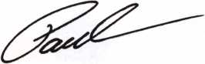

Paul Kanitra • Government Relations Manager



Keynotes • December 2003



EMPLOYMENT

FKI SECURITY GROUP SEEKS QUALIFIED TECHNICIANS FOR NEW FIELD SERVICE DIVISION

In response to continuing and growing demand for field service, FKI Security Group has established the FKI Field Ser­vices division to support NKL Cash Handling products and is seeking qualified technicians in major metro markets. Techni­cians will support business development and new service con­tracts for NKL Cash Handling, which include electronic bill- counters or validators, dispensing safes and access control safes. Each field technician will be equipped with a state of the art communications system and all the necessary parts and tools to service all of FKIfs security products.

The markets currently open are, Baltimore/ Washington DC, New Jersey/Metro New York, North/Central Ohio, Dallas, Houston, Orlando/Central Florida, Northern California, Sacra­mento/East Bay, Southern California, Phoenix

Highly competitive compensation and a complete benefits package including health, dental, and vision insurance, 401K plan, and fully paid expenses will be offered to qualified tech­nicians. Technicians with the experience servicing safes, locks, ATMs or POS systems will be considered. This position can grow into a management position as the division expands.

Interested parties should contact Christina Lvell at 800-457- 2424 or e-mail your resume to chrisl@fkisecurit/group.com"



SECURITY GROUP

101 Security Parkway • New Albany, IN 47150

STOP LOOKING!!!!!

EXPERIENCED TECHNICIANS WANTED

Lock into your future now! If you are experienced, intelli­gent, and desire a secure future, come join our team. We are a full service commercial/residential security service (locks, keys, safes, CCTV, access control, door related hardware). We offer: top wages, company vehicle, 401k, paid vacation, paid holidays, new uniforms, cross training, and job satisfac­tion. We are looking for the best techs who are ready to be treated and compensated as professionals.

Bass Security Services, Inc.

Ph#216-755-1200 ex.# 128

Fax#216-755-1220

E-MAIL / [rmesnick@bass-security.com](mailto:rmesnick@bass-security.com)

TURH1©

WHOLESALE SERVICE

**800-848-9790**

**One Call Gets You...**

**Amsec, Gardall  
Hayman, Meilink  
Victor, Winchester**

**Plus Free Delivery  
From America's  
Largest Inventory  
of Safes.**

WANTED TO BUY/SELL

FOR SALE

Original Schlage blanks in 5-pin EF keyway or 6-pin in CE, EF,

FG or G keyway at $ 12.50 per box of 50. Contact George Thomas at 218-724-3416 or write to 825 Woodlandd Ave., Duluth MN 55812-2168

WHOLESALE SAFE DEPOSIT LOCKS

Allied, Diebold, Herrin, Hall & Mavin, llco, Lefabure, Mosler, Precission, S&G, Security Corp., Yale. Locks from early 1900s to current. Call or email for lock type and pricing sheet. Quantity discounts. Call WBI at (954)484-2404 or email: [sales@wbi.us](mailto:sales@wbi.us)

FOR SALE

Owner retired. Framon Model 2 w/ manual and Scotsman Model 747XU w/ manual. Like new. Reed code books 1, 2, 3, 4 and 5. Call 919/676-8490.

You need it When?

**How about now!? :-)**

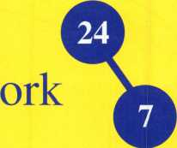

Another Special  
Value-added Benefit to your

ALOA Membership! Click here

iL

[www.clearstar.com](http://www.clearstar.com) / ALOA

BUSINESS FOR SALE

BUSINESS FOR SALE

A small, quite successful business for sale in south Orange  
County, California. Three Rytan machines, three HPC code  
machines, HPC code books, coding program, tools for "luxury"  
vehicle lockouts - all parts, tools and supplies to keep two trucks  
on the road full time. One truck on the road provides $10-1 IK per  
month. Truck, which is the Ford F250 van with advertising sig-  
nage, built-in work areas and cabinetry - can be part of the pack-  
age or purchased separately. Low operating costs after 10 years  
of building the business. Advertising expenses 10 years ago? $4K  
per month. Now we pay a fifth of that. This is a nice set-up for  
someone to step in and take over. Existing accounts (which bring  
in about $8200/month include three in property management  
and eight auto dealerships. We'll work to set you up with our  
existing accounts. All reasonable offers will  
be considered. Call 949/370-9619, or  
fax 949/458-1733.

MOBILE LOCKSMITH BUSINESS FOR SALE

Speedex duplicator, van, tools, code books, two HPC code  
machines (Blitz), inventory, some hardware. $6000 (firm).

Call 601/916-6448.

LOCKSMITH FRANCHISE AVAILABLE

Low cost, complete training, national Franchise call  
(925) 260-7373 • [www.SpeedyLocksmiths.com](http://www.SpeedyLocksmiths.com) .

V

J

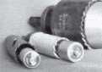

Hole Saw g Alignment Guides

No More Plywood, "C" Clamps, or *Jigs*Needed to Over Bore Existing *Holes*

* Our Guides let you over bore existing holes that meas. 5/8”, 3/4" & 1-1/2" diameter
* They work on wood as well as metal
* Two small sizes ideal for desks and cabinets
* Purchase in sets or individually
* Visa, MC, Amex, Discover MONEY-RACK GUARANTEE

Daniel D. Mello, Owner-Locksmith  
Groveland, CA

209 962 4692 • 209 962 4910 FAX E-mail: [slmello@mlode.com](mailto:slmello@mlode.com) **[www.tricitylock.com](http://www.tricitylock.com)**

*Classified* Advertising Policy

Classified advertising space is provided free of charge to ALOA members, and for a fee of $.60 per word, $ 15 minimum for non­members. Classified ads may be used to advertise used merchandise and over­stocked items for sale, "wanted to buy" items, business opportunities, employment opportunities/positions wanted and the like. Members or non-members wishing to advertise services or new merchandise for sale may purchase a "Commercial Classified Ad," for a fee of $1.30 per word, with a minimum of $40. Each ad will run for two issues. For blind boxes there is a $5 charge to members and non-members. All ads must be submitted in writing to the ALOA office by the fifteenth of the month, two months prior to issue date. Send to Keynotes Classifieds, 3003 Live Oak St., Dallas TX 75204-6186. ALOA reserves the right to refuse any classified advertise­ment that it deems inappropriate according to the stated purpose of the classified advertising section.

**assa**

Family Of Locks

***iwin.***

Door Tube Lock

Cam Lock

ASSA Canada 3475 14th Avenue Markham, Ontario L3R 0H4 Canada

www, assalock. com

ASSA, Inc.

110 Sargent Drive New Haven, CT 06511 (800) 235-7482 Fax (800) 892-3256

We Secure The World

ASSA ABLOY

an ASSA ABLOY Group company

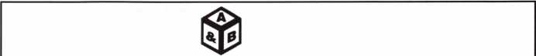

SAFE CORPORATION

MANUFACTURES OF QUALITY DEPOSITORY SAFES AND CHESTS

DISTRIBUTING FROM WAREHOUSES IN

* LOS ANGLES, CA
* CHICAGO, IL
* GLASSBORO, NJ

A & B is now a stocking distributor

for Mutual Safes

i

AB-4-30-3S AB-9-2 WS 10-2

Chose from over 75 models in stock

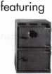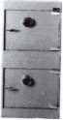

We ship your order within

24 hours

See us

*at [www.a-bsafecorp.com](http://www.a-bsafecorp.com)*800-253-1267  
Fax 856-863-1208

CALL FOR YOUR  
CATALOG TODAY

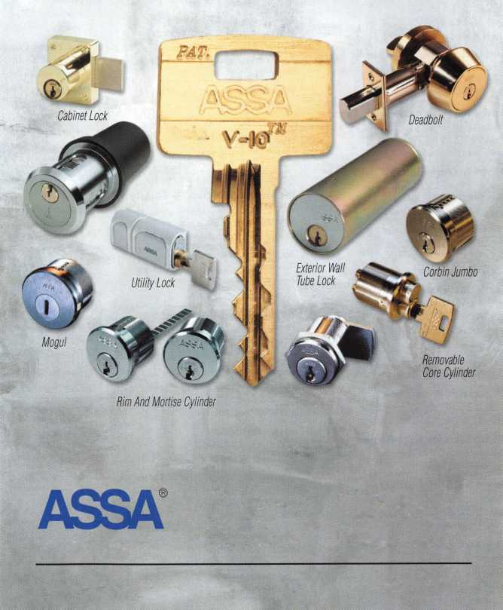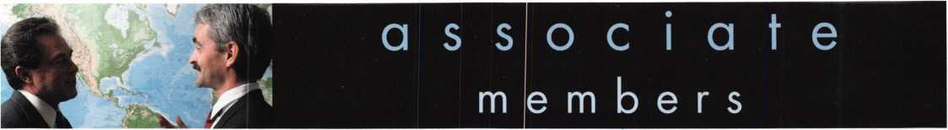

Distributor

ADI Inc.

Phone: 631-692-1000 Fax: 631-692-3011

Accredited Lock Supply Co.

Phone: 201-865-5015 Fax: 201-865-0030 [www.acclock.com](http://www.acclock.com)

Ace Lock & Security Supply

Phone: 908-688-7666 Fax: 908-688-2442 [www.acelock.com](http://www.acelock.com)

Andrews Wholesale Lock Supply

Phone: 717-272-7422 Fax: 717-274-8659 [www.andrewslock.com](http://www.andrewslock.com)

Boyle & Chase Inc.

Phone: 800-325-2530 Fax: 800-205-3500 [www.boyleandchase.com](http://www.boyleandchase.com)

Chinrose International

Phone: 503-357-7553 Fax: 503-357-5522 [www.chinrose.com](http://www.chinrose.com)

Clark Security Products

Phone: 800-854-2088 Fax: 619-974-5284 [www.clarksecurity.com](http://www.clarksecurity.com)

Cook's Building Specialties

Phone: 505-883-5701 Fax: 505-883-5704

Dire's Lock & Key Company

Phone: 303-294-0176 Fax: 303-294-0198

Direct Security Supply, Inc.

Phone: 800-252-5757 Fax: 800-452-8600

Doyle Security Products

Phone: 800-333-6953 Fax: 612-521-0166 [www.doylesecurity.com](http://www.doylesecurity.com)

Dugmore and Duncan, Inc.

Phone: 888-384-6673 Fax: 888-329-3846

E. L. Reinhardt Co., Inc.

Phone: 800-328-131 1 Fax: 651-481-0166 [www.elreinhardt.com](http://www.elreinhardt.com)

Ewert Wholesale Hardware

Phone: 800-451-0200 Fax: 708-597-0881

Fairway Supply, Inc.

Phone: 214-350-0021 Fax: 214-352-4299 [www.fairwaysupply.com](http://www.fairwaysupply.com)

Foley-Belsaw Company

Phone: 800-821-3452 Fax: 816-483-5010 [www.foley-belsaw.com](http://www.foley-belsaw.com)

Fried Brothers Inc.

Phone: 800-523-2924 Fax: 215-592-1255 [www.fbisecurity.com](http://www.fbisecurity.com)

H L Flake Co.

Phone: 800-231-4105 Fax: 713-926-3399 [www.hlflake.com](http://www.hlflake.com)

H.S. & S. Wholesale Distrib.

Phone: 313-342-6777 Fax: 313-342-7580

Hans Johnsen Company

Phone: 214-879-1550 Fax: 214-879-1530 [www.hjc.com](http://www.hjc.com)

Hardware Agencies, Ltd.

Phone: 416-462-1921 [www.hardwareagencies.com](http://www.hardwareagencies.com)

IDN Incorporated

Phone: 817-421-5470 Fax: 817-421-5468 [www.idn-inc.com](http://www.idn-inc.com)

Intermountain Lock & Supply

Phone: 800-453-5386 Fax: 801-485-7205 [www.intermountainlock.com](http://www.intermountainlock.com)

Jo Van Distributors

Phone: 416-752-2238 Fax: 416-752-7282 [www.jovanlock.com](http://www.jovanlock.com)

KeylessRide

Phone: 877-619-3136 Fax: 409-216-5058 [www.keylessride.com](http://www.keylessride.com)

Lockmasters, Inc.

Phone: 859-885-6041 Fax: 859-885-7093 [www.lockmasters.com](http://www.lockmasters.com)

Locks Company

Phone: 800-288-0801 Fax: 305-949-3619

Locksmith Ledger International

Phone: 770-886-0800 Fax: 770-889-7703 [www.lledger.com](http://www.lledger.com)

M. Zion Company

Phone: 212-349-8677 Fax: 212-964-0495 [www.mzion.com](http://www.mzion.com)

McDonald Dash Locksmith Supp

Phone: 800-238-7541 Fax: 901-366-0005 [www.mcdonalddash.com](http://www.mcdonalddash.com)

McManus Locksmith Supply, Inc.

Phone: 704-333-9112 Fax: 704-332-8664

Monaco Lock Co.

Phone: 800-526-6094 Fax: 800-845-5625 [www.monacolock.com](http://www.monacolock.com)

Omaha Wholesale Hardware

Phone: 800-238-4566 Fax: 402-444-1664 [www.omahawh.com](http://www.omahawh.com)

Phoenix Safe International LLC

Phone: 765-483-0954 Fax: 765-483-0962 www. phoen ixsafeusa .com

Professional Business Products

Phone: 248-360-3979

Fax: 248-360-3982

[www.professionalbusinessproducts](http://www.professionalbusinessproducts).

RA-Lock Company

Phone: 972-775-6301 Fax: 972-775-6316 [www.ralock.com](http://www.ralock.com)

S J Hope Products

Phone: 702-260-7645 Fax: 702-837-1465

SNA Inc.

Phone: 678-206-0381 Fax: 678-206-0382 [www.sungil-safe.com](http://www.sungil-safe.com)

Secure Rite.Com

Phone: 800-241-3930 Fax: 858-974-5269 [www.SeiCureRite.Corn](http://www.SeiCureRite.Corn)

Security House

Phone: 905-669-5300 Fax: 905-660-6313 [www.seeurityhouselock.com](http://www.seeurityhouselock.com)

Security Lock Distributors

Phone: 800-847-5625 Fax: 800-878-6400 [www.seicuradealer.com](http://www.seicuradealer.com)

Sentry' Security Fasteners

Phone: 309-693-2800 Fax: 800-693-2872

Somerset Security Products

Phone: 800-881-5206 Fax: 800-206-9949

Southern Lock and Supply Co.

Phone: 727-541-5536 Fax: 727-544-8278 [www.southernlock.com](http://www.southernlock.com)

Stone & Berg Wholesale

Phone: 800-225-7405 Fax: 800-535-5625

The Locksmith Store Inc.

Phone 847-364-5111 Fax: 847-364-5125 [www.locksmithstore.com](http://www.locksmithstore.com)

Timemaster Inc.

Phone: 859-259-1878 Fax: 859-255-0298 [www.rime-master.com](http://www.rime-master.com)

Top Notch Distributors, Inc.

Phone: 800-233-4210 Fax: 800-854-4146 [www.4topnotch.com](http://www.4topnotch.com)

Turn 10 Wholesale

Phone: 800-848-9790 Fax: 800-391-4553

U.S. Lock Corp.

Phone: 800-925-5000 Fax: 800-338-5625 [www.uslock.com](http://www.uslock.com)

Wilco Supply

Phone: 800-745-5450 Fax: 510-653-5397 [www.wilcosupply.com](http://www.wilcosupply.com)

Manufacturer

A & B Safe Corporation

Phone: 800-253-1267 Fax: 856-863-1208 [www.a-bsafecorp.com](http://www.a-bsafecorp.com)

ABUS Lock Company

Phone: 800-352-2287 Fax: 602-516-9934 [www.abus.com](http://www.abus.com)

Abloy Door Security

Phone: 800-465-5761 Fax: 514-335-0430 [www.abloy.com](http://www.abloy.com)

Adams Rite Mfg Company

Phone: 800-872-3267 Fax: 800-232-7329 [www.adamsrite.com](http://www.adamsrite.com)

Adesco Safe Mfg. Company

Phone: 800-694-9340 Fax: 562-408-6427 [www.adesco.com](http://www.adesco.com)

Adrian Steel Company

Phone: 800-677-2726 Fax: 517-265-5834 [www.adriansteel.com](http://www.adriansteel.com)

Alarm Lock Systems Inc.

Phone: 800-252-5625 Fax: 516-789-3383 [www.alarmlock.com](http://www.alarmlock.com)

All Five Tool Company, Inc.

Phone: 860-583-1691 Fax: 860-583-4516 [www.all5tool.com](http://www.all5tool.com)

American Lock Company

Phone: 708-534-2000 Fax: 708-534-0531 [www.armericanlock.com](http://www.armericanlock.com)

American Security Products

Phone: 909-685-9680X1083 Fax: 909-685-9685 [www.amsecusa.com](http://www.amsecusa.com)

BWD Automotive

Phone: 334-872-6524 Fax: 334-874-601 1 [www.bwdautomotive.com](http://www.bwdautomotive.com)

Baldwin Hardware

Phone: 610-796-4012 Fax: 610-796-4493 [www.baldwinhardware.com](http://www.baldwinhardware.com)

Be-Tech Security Systems Ltd.

Phone: 852-231-67447 www. be-tech .com. h k

Bianchi USA, Inc.

Phone: 800-891-2118 Fax: 216-803-0202

Buddy Products

Phone: 800-886-8688 Fax: 312-733-8356 [www.buddyproducts.com](http://www.buddyproducts.com)

CCL Security Products

Phone: 800-733-8588 Fax: 847-537-1800

COMPX Security Products

Phone: 864-297-6655 Fax: 864-297-9987 [www.nclnet.com](http://www.nclnet.com)

Keynotes • December 2003

**associate**

**members**

Curtis Industries,

A Barnes Distributor

Phone: 800-555-5397 Fax: 800-867-6020 [www.curtisindustries.com](http://www.curtisindustries.com)

D&D Technologies (USA), Inc.

Phone: 714-677-1300X292 Fax: 714-677-1299 [www.ddtechusa.com](http://www.ddtechusa.com)

DETEX Corporation

Phone: 800-729-3839 Fax: 830-620-6711 [www.detex.com](http://www.detex.com)

DORMA Architectural Hardware

Phone: 717-336-3881 Fax: 717-336-3500 [www.dorma-usa.com](http://www.dorma-usa.com)

Datakey Electronics

Phone: 800-328-8828 Fax: 866-289-4212 [www.datakeyelectrnics.com](http://www.datakeyelectrnics.com)

Don-Jo Manufacturing, Inc.

Phone: 978-422-3213 Fax: 978-422-3467 [www.don-jo.com](http://www.don-jo.com)

Door Controls International

Phone: 800-742-3634 Fax: 800-742-0410 [www.doorcontrols.com](http://www.doorcontrols.com)

ESP Lock Products Inc.

Phone: 978-562-3481 Fax: 978-562-9859

FireKing Security Products

Phone: 800-457-2424 Fax: 800-896-6606 [www.fireking.com](http://www.fireking.com)

Framon Manufacturing Company Inc.

Phone: 989-354-5623 Fax: 989-354-4238 [www.framon.com](http://www.framon.com)

HES, Inc.

Phone: 623-582-4626 Fax: 623-582-4641 [www.hesinnovations.com](http://www.hesinnovations.com)

HPC, Inc.

Phone: 847-671-6280 Fax: 847-671-6343 [www.hpcworld.com](http://www.hpcworld.com)

HY-KO Products Co.

Phone: 440-232-8223X3095 Fax: 440-232-8227

Hongtai Lock Co. Ltd.

Phone: 137-238-1414 Fax: 208-793-3856

INTELLIKEY Corp.

Phone: 800-226-0703 Fax: 321-724-0811 [www.intellikey.com](http://www.intellikey.com)

Jet Hardware Mfg., Co.

Phone: 718-257-9600 Fax: 718-257-0973 [www.jetkeys.com](http://www.jetkeys.com)

KABA High Security Locks

Phone: 860-621-3601 Fax: 860-621-9727 [www.kabausa.com](http://www.kabausa.com)

KABA ILCO Corp.

Phone: 252-446-3321 Fax: 252-446-4702 [www.kaba-ilco.com](http://www.kaba-ilco.com)

KEY-BAK/West Coast Chain Mfg.

Phone: 909-923-7800 Fax: 909-923-0024 [www.keybak.com](http://www.keybak.com)

Keri Systems Inc.

Phone: 408-451-2520 Fax: 408-441-0309 [www.kerisys.com](http://www.kerisys.com)

Knaack Manufacturing Co.

Phone: 800-456-7865 Fax: 815-459-9097 www. wea th e rguard.com

LAB Security

Phone: 800-243-8242 Fax: 860-583-7838 [www.labpins.com](http://www.labpins.com)

LCN Closers/Div of Ingersoll

Phone: 815-875-3311 Fax: 815-879-1497 [www.lcnclosers.com](http://www.lcnclosers.com)

La Gard Inc.

Phone: 310-325-5670 Fax: 310-325-5615 [www.lagard.com](http://www.lagard.com)

Lock America, Inc.

Dba L.A.I. Gro.

Phone: 714-373-2993 Fax: 714-373-2998 [www.laigroup.com](http://www.laigroup.com)

Lucky Line Products, Inc.

Phone: 858-549-6699 Fax: 858-549-3241 [www.luckyline.com](http://www.luckyline.com)

M.A.G. Security

Phone: 714-891-5100 Fax: 714-892-6845 [www.magsecurity.com](http://www.magsecurity.com)

MARKS, U.S.A.

Phone: 516-225-5400 Fax: 516-225-6136 [www.marksusa.com](http://www.marksusa.com)

MARRAY ENTERPRISES

Phone: 408-970-0213 Fax: 408-970-8767 [www.marray.com](http://www.marray.com)

MCS Communication Systems

Phone: 450-444-2040X225 Fax: 450-444-4856 [www.mcscommunication.com](http://www.mcscommunication.com)

MMD, Inc.

Phone: 865-428-3611 Fax: 865-453-4136

MUL-T-LOCK USA, Inc.

Phone: 800-562-3511 Fax: 973-778-4007 [www.mul-t-lock.com](http://www.mul-t-lock.com)

Master Lock Company

Phone: 414-444-2800 Fax: 414-444-0322 [www.masterlock.com](http://www.masterlock.com)

Medeco Security Locks

Phone: 540-380-5000 Fax: 540-380-5010 [www.medeco.com](http://www.medeco.com)

Mustang Company

Phone: 574-674-0053 Fax: 574-675-9603

NKL Industries Inc.

Phone: 800-528-9900 Fax: 757-485-0271 [www.nklindustries.com/products_NK](http://www.nklindustries.com/products_NK)

OSI Security Devices

Phone: 619-628-1000 Fax: 619-628-1001 [www.omnilock.com](http://www.omnilock.com)

Pro Steel

Phone: 801-373-2385 Fax: 801-373-2399 [www.prosteel.us](http://www.prosteel.us)

ROFU International Corp.

Phone: 800-255-7638 Fax: 253-922-1728 [www.rofu.com](http://www.rofu.com)

Rutherford Controls Int'l. Co.

Phone: 757-427-1230 Fax: 757-427-9549 [www.rutherfordcontrols.com](http://www.rutherfordcontrols.com)

STRATTEC Security Corp.

Phone:414-247-3415 Fax: 414-247-3692 [www.strattec.com](http://www.strattec.com)

Sargent & Greenleaf, Inc.

Phone: 859-885-941 1 Fax: 859-885-3063 [www.sargentandgreenleaf.com](http://www.sargentandgreenleaf.com)

Sargent Manufacturing Co.

Phone: 203-562-2151 Fax: 203-776-5992 [www.sargentlock.com](http://www.sargentlock.com)

Schlage Lock Co.

Phone: 719-264-5300 Fax: 719-264-5382 [www.schlagelock.com](http://www.schlagelock.com)

Schwab Corp.

Phone: 765-447-9470 Fax: 765-447-8278 [www.schwabcorp.com](http://www.schwabcorp.com)

Secure-UR-Home

Phone: 905-771-7300 Fax: 905-771-7304

Securitron Magnalock Corp.

Phone: 775-355-5625 Fax: 775-355-5636 [www.securitron.com](http://www.securitron.com)

Security Door Controls

Phone: 805-494-0622 Fax: 805-494-8861 [www.sdcsecurity.com](http://www.sdcsecurity.com)

Security Solutions

Phone: 405-376-1600 Fax: 405-376-6870 [www.securitysolutions-usa.com](http://www.securitysolutions-usa.com)

Sully Tools Inc.

Phone: 703-689-3416 Fax: 703-787-0869 [www.sullytools.com](http://www.sullytools.com)

Sun Safes Manufacturing Co.

Phone: 823-194-59300 Fax: 823-194-59400 [www.eaglesafes.com](http://www.eaglesafes.com)

Taylor Security & Lock

Phone: 410-646-9900 Fax: 410-646-0045 [www.taylorsecurity.com](http://www.taylorsecurity.com)

Taymor Industries, Inc.

Phone: 800-388-9887 Fax: 800-288-8133

Townsteel, Inc.

Phone: 626-858-5080 Fax: 626-858-3393

Trine Access Technology

Phone: 718-829-2332 Fax: 718-829-6405 [www.trineonline.com](http://www.trineonline.com)

Victor E-lok, Inc.

Phone: 949-916-1200 Fax: 949-916-1300 [www.victorelok.com](http://www.victorelok.com)

Videx Inc.

Phone: 541-758-0521 Fax: 541-752-5285 [www.videx.com](http://www.videx.com)

W-LOK Corporation

Phone: 616-355-4015 Fax: 616-355-4295 [www.wlokcorp.com](http://www.wlokcorp.com)

YSG Door Security Consultants, Inc.

Phone: 800-438-1951 Fax: 800-338-0965

Service Organization

1-800 Locksmith 1994 Inc.

Phone: 800-562-5764 Fax: 718-236-4504 www. 1 800locksmith.net

Allstate Insurance Company

Phone: 800-859-0247 Fax: 847-326-7509 [www.allstate.com](http://www.allstate.com)

Cross Country Automotive Services

Phone: 800-541-2262 Fax: 781-393-0256 [www.argosi.com](http://www.argosi.com)

Emergency Road Service Inc.

Phone: 888-839-5386 Fax: 678-277-8105

Massglass & Door Service

Phone: 888-742-8837 Fax: 805-497-2255 [www.massglass.com](http://www.massglass.com)

The National Locksmith

Phone: 630-837-2044 Fax: 630-837-1210 [www.thenationallocksmith.com](http://www.thenationallocksmith.com)

The Security Professionals

Phone: 866-486-1938

Fax: 856-486-0401

[www.thesecurityprofessionals.com](http://www.thesecurityprofessionals.com)

Webster Safe & Lock Co., Inc.

Phone: 901-332-2911 Fax: 901-332-2878

[www.webstersinc.com](http://www.webstersinc.com) ^_

Keynotes • December 2003

back page

About the Authors

Claire Cohen, the second woman to become a CML, has been in lock- smithing since 1977 and has been writing articles for Keynotes since 1987. She is also a contributing editor for Keynotes, and was just named the 2001 Keynotes Author of the Year - again, the second woman to achieve that honor.

Eric Costley, CRL, has been active in the locksmith industry since 198G. He has a bachelor's degree from Gardner-Webb University, and has worked in shops in Arizona, North Carolina, and New York. He is cur­rently employed by Bill's Locksmithing in Elmira, New York. Eric's hob­bies include music and raising tarantulas.

Raymond D’Adamo, CML is originally from Hoboken, NJ. In 1973 he graduated Rutgers University and in 1977 he began locksmithing in Boulder, CO. In 1981 he began writing automotive locksmithing tech­nical articles for locksmith publications, and began instructing automo­tive locksmithing courses at trade association meetings and conven­tions. In 1983 he and his wife Tina D’Adamo moved to Fort Collins, CO and opened Fort Security Center. Since then their business, TRI­CITY Security, has grown to two additional facilities in Greeley and Loveland, CO. Ray is an active member of ALOA since 1978 and con­tinues to contribute to the education of locksmiths all over the world.

Ray Iglesias, CPL, owns and operates Safeguard Lock and Safe in Ft. Lauderdale, FL.

Greg Perry, CML, CPS, has been in the locksmith industry for 20 years. He's spent half of that time as a field technician for Security Engineering in Ridgecrest, CA. Greg is also a past president of the Desert Counties Chapter of the California Locksmiths Association. He has also won the 2002 Keynotes Author of the Year Award. You can e-mail him at [glm- perry@iwvisp.com](mailto:glm-perry@iwvisp.com).

David E. Thielen, CML is the lockshop manager for Adams Twelve Five Star School District, Broomfield, Colorado. He has been a profession­al locksmith for more than 15 years a member of RMLA and DHI and a member of ALOA since 1985. He has instructed classes for the Rocky Mountain Locksmiths Association and has developed and instructed ACE certified classes for ALOA at regional and national con­ventions.

Richard L. Dyer, CRL, CPS, CJS, is the owner of J & R Lock and Key Service, LLC in Colorado Springs, CO.

**r ^**

Accurate Manufacturing 1

Stam 3

TLA 9

DHI 1 1

OSI 22

STB 23

A&B Safe 31,41

Professional Business Products 31

Turn 10 40

Tri-City Lock 40

Clearstar Network 41

Hickok Back Cover

**Ad Index**

L. J

Keynotes • December 2003



*those who passed over it on their way to Virginia City and the gold recently discovered there. Fuller also provided gold-seekers with a place to rest, purchase a meal, and exchange information with other*

***prospectors.***

Keeping up with the latest the industry has to offer has never been more impor­tant for safe technicians. Time is of the essence when it comes to education. New developments spring up each year, making top-notch safe classes as good as gold in our ever-changing environment. The only chance to get world-class education and meet with the industry's top safe technicians and suppliers is the SAFETECH Convention and Trade Show. SAFETECH 2004 offers you a chance to explore your profession in ways you never thought possible. Register now to benefit from the future of this exciting industry.

*mod/*

**SAFETECH 2004**

MARCH 20-28  
JOHN ASCUAGAS  
NUGGET RESORT  
RENO, NEVADA

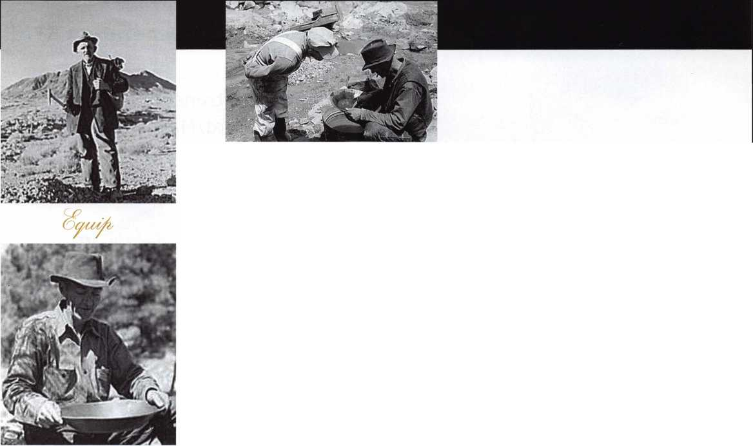

**(Tour  
Key to**

**Jnlocking**

— -

**You're never on your own..**

**Toll Free Tech Support**

**1-800-342-5080**

"I've lost my Taurus keys... can you make a new set#* \J

How much of your money have you sent to the / local Ford dealer?

S008LA New Generation STAR



Use the Ford factory too; to  
program transponder keys for  
ALL Ford/Mazda vehicles.

Keep the money in your pocket!

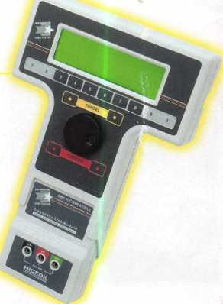

NGS

Complete

Ford/Mazda

transponder

coverage

PLUS the

ability to clear ALL

Diagnostic

Service Codes

Say "YES" to  
$100 phone calls



HICKOK

